Effects accompanying reverse EMF

Dedicated to all true lovers of natural science.

Deina Sergey Alekseevich

1. Introduction

Judging by the comments to the video, many visitors to the channel were disappointed with the information about two reciprocal physical phenomena, the EMF of self-induction and the reverse EMF, hoping for some increase in energy is the same as hoping for an increase in energy from a kickback . Perhaps many, even dropped their hands. I think that this should not be done.
But in addition to transverse interactions, there are also longitudinal interactions. What do we know about them? - Very little. Let's try to correct this situation a little.
Everyone knows that the physical vacuum is characterized by two parameters - the magnetic permeability μ and the dielectric constant ε. The remaining parameters will not be considered yet. It turns out that the World environment simultaneously has two properties - a ferromagnet and a dielectric? This will be another topic in due time.
The transverse effects should be associated with the magnetic permeability μ, and the longitudinal effects with the dielectric constant ε. This is not the place to engage in the proof of this statement, but to show the prospects for this it can and should be.
It is known that the mechanical deformation of any physical body (including, of course, the World environment) is always accompanied by two effects - magnetostrictive and piezoelectric, although all in different degrees.
The magnetostrictive effect is reversible. It lies in the fact that during deformation (mechanical loads) of physical bodies their magnetic properties change and vice versa, bodies that fall into a magnetic field change their dimensions as if they were subjected to physical deformation.
In the “reverse emf” video I mentioned that the magnetic environmental impact is transverse. What does this mean? This means that in the middle zone, the magnetic effect in free space decreases with distance from the observation point in a cubic dependence, and to a far greater degree - in the fourth degree. This makes magnetic interactions practically unpromising in terms of energy transfer over a distance.
The piezoelectric effect is also reversible. It lies in the fact that during deformation of physical bodies, their electrical properties change (the direct piezoelectric effect is polarization of dielectrics) and vice versa, bodies that fall into an electric field change their dimensions as if they were subjected to physical deformation.
Let me remind you that the longitudinal waves in the World environment consists in its deformation in the form of propagating longitudinal waves of compression and rarefaction — these are environments that propagate freely in all directions. Longitudinal waves have the property that the collapse of neutral dipoles is observed in the compression zone of the World environment, and in the rarefaction zone, their recombination back into neutral dipoles. These dipoles fill the entire World Environment without intervals, and consist only of two elementary electric opposite electrical charges. This has already been said in the video "Ether is - the global environment", which can be found on the link: https://www.youtube.com/watch?v=v7e0L0oWUeU. Вот в
this is all wisdom.
Thus, as mentioned above, the deformation of any medium is always accompanied by magnetic and electric phenomena. But the magnetic deformation waves propagate poorly in the medium, so we will only talk about the electric waves that always are accompaining the deformation of the medium.
It must be remembered that compression waves, in which as a result of the collapse of dipoles, pairs of free electric charges appear, are always neutral, since the number of released opposite charges is always equal. Nevertheless, we have a chance to polarize the compression wave and separate the charges in it. Further, as they say - the matter of technology.
As for discharge waves in a medium where pairs of opposite charges combine to form dipoles, we also have the opportunity to influence them, in the form of medium polarization, since neutral dipoles still have an incompletely neutralized electric charge, which gives them gravitational interaction with each other.
The term and concept of bias current was derived artificially and does not reflect the properties of longitudinal waves, which it was intended to replace. In the video “Magnets. The second magnetic field of Nikolaev - 6 (repeat) "(which can be viewed at the link: https://www.youtube.com/watch?v=4xjnOjM503U) I have shown that the longitudinal waves are practically unscreenable and propagate freely. Therefore, if we talk about the transmission of energy over a distance, then this can and should be done not with the help of transverse magnetic waves of the deformation of the world environment, but with the help of longitudinal electric waves of deformation of the world environment. This is what should be done by those who decided to create a BTG. I think that what has been said above is enough to understand the purpose of the series of experiments presented to the attention of the general public in this work.

1. Preparation for the experience

For the experiment, an inductance coil with a closed core, a switch and a generator of rectangular pulses were used, and several devices were prepared, some words should be said separately:

1) electric charge sign indicator;

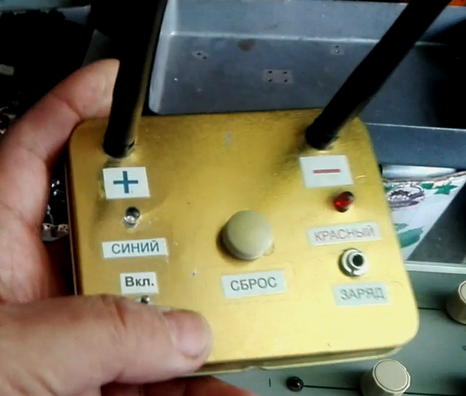

2) longitudinal wave recorder;
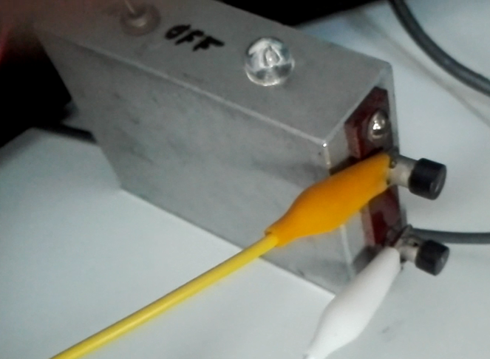

3) electrostatic voltmeter;
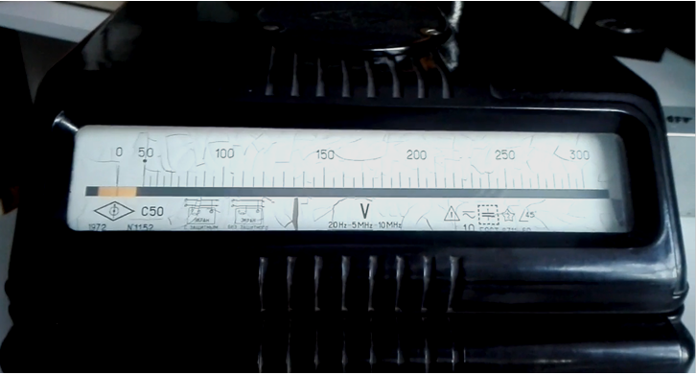

4) Electrostatic kilovoltmeter.
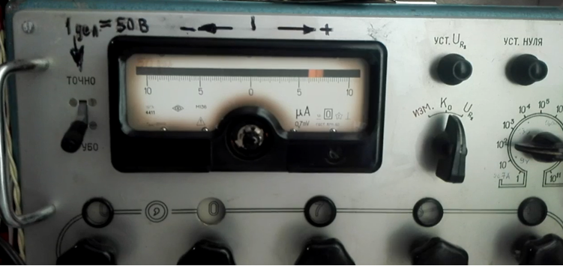
We watch a small video clip:

1. High voltage?

In this part of the experiments, the frequency of rectangular pulses was reduced from 5 kHz to 1.5 kHz.
Short and unshort circuit in the inductance coil leads to a sharp change in the value of the back EMF, which is clearly seen on the two oscillograms below.
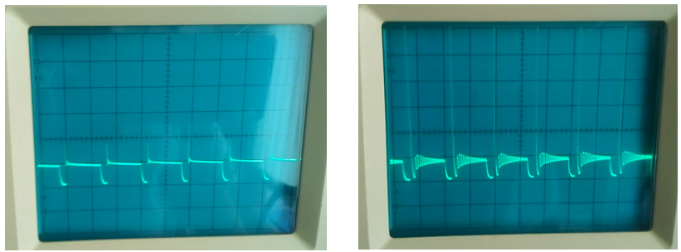

Now compare that registers an electrostatic kilovoltmeter with the same switching short circuit. To do this, we connect an electrostatic kilovoltmeter cable to the drain of the field-effect transistor instead of the oscilloscope probe, as seen in the photo below.
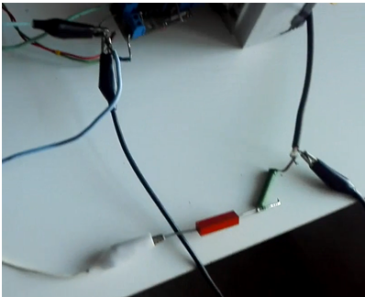

I have already shown that the recorder of the electric charge mark does not register the electric charge on the drain of the field-effect transistor. But, having connected a high-voltage capacitor through the diode to the drain of the transistor, we were convinced that the capacitor is being charged to a high voltage of about 400 - 800 Volts. Why doesn't the recorder detect it?
It is surprising that the electrostatic kilovoltmeter connected to the common wire and to the drain of the field-effect transistor through a high-voltage diode registers a voltage similar to that in electrostatics, the value of which reaches in this case 20 kV positive sign. But this field is different from the electrostatic field. This is proved by the fact that the capacitor charges only up to 300-600 V, and the electrostatic kilovoltmeter shows about 12-16 kV.
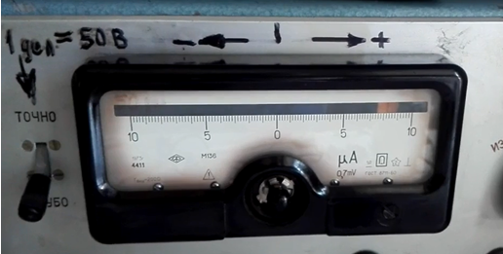

In the “rough” position of the mode switch of this device, all its readings should be multiplied by 2500: Therefore, in the photo above the light pointer shows the voltage value 8.3 x 2500 = 20750 Volts. It remains to think why we can not remove these kilovolts?
I think that the answer here is only one - the device registers not an electrostatic field, but electric longitudinal waves, which should be handled differently than with ordinary transverse waves or electrostatic potentials.
Watch the following video clip:

2. Longitudinal wave or strange beam oscilloscope behavior?

Previously, the strange behavior of the oscilloscope beam was detected, which was shown in the video "Registration of Radiant Energy" which can be viewed by reference. https://youtu.be/X78hsfmgYpk.
Many have said and now claim that these are “glitches”, that is, a violation of the proper operation of the oscilloscope. Let us show that this is not the case.
In the light of the previous, it turns out that radiant radiation is the propagation of electrical longitudinal waves by ether deformation. Another name for radiant radiation is radio waves, but they are not electromagnetic, as they everywhere write about and painstakingly draw.
If anyone remembers, earlier - at the time of tube radio receivers, people said: “What does it sound on the air?”.
As for electromagnetic waves, this term is coined artificially and has no relation to reality. Build a physical model to fit the desired result, you can do anything, but it does not necessarily reflect the truth.
If you take a source of magnetic radiation and measure its intensity at a distance of 1 cm, then the intensity of this radiation at a distance of 1 meter will decrease and will be 1: = 0.03 part of this value. How with such indicators to hope for the transfer of energy at a distance using the magnetic component, if there is one? I do not know what's so difficult to understand this? Apparently, three proven things work - this is the authority of a scientist, the clarity of the illustrations and the pattern: if you say 100 times that the soup is sour, then for many it will really become sour.
As already mentioned, the concept of bias current does not reflect the true properties of longitudinal waves. Maxwell created another crude theory, which he wrote and pointed to. Hertz picked it up and published it and left its physical model. Marconi continued their work. No conversation of N. Tesla with Marconi (who in America is considered the inventor of the world's first radio receiver), that his ideas about the radio wave are wrong, the results did not prove. Apparently, in those days, they also paid grants and made the necessary orders to scientists.
The term radio waves was derived artificially and has no relation to reality, and the formulas for calculating the characteristics of radio waves are entirely based on empirical data and fitting. The first to suspect this and openly speak in the press is KP Kharchenko. Read his article “ANATOMY OF A REAL RADIO WAVE” or the brochure “Radiant Energy”, as well as some of his other works that can now be found on the Internet and you will understand what is being said.
On the Internet, you can find a channel called Alex Org. In it, a talented researcher and inventor showed the work of standing-wave recorders N. Tesla and A. Popova. Watch his video titled “Receiver (recorder) of standing waves of Nikola Tesla: click here: https://youtu.be/2JN-rIcEM4I.
It is necessary to correct the author, that he made the receiver not of standing, but of longitudinal electric waves, which propagate from lightning discharges. For the appearance of a standing wave, reflection from something is necessary, and in open space a longitudinal wave can be reflected simultaneously from anything.
Yes, the study of radio waves began precisely with electrical and lightning discharges, and the first radio receiver Popov was called the Thunderbolt.
A few years ago, I decided to assemble a detector of longitudinal electric waves, when I did not know about N. Tesla's work on recording longitudinal waves. Therefore, in my device there is no capricious coherer and bulky coils. My detector was lightweight, small and highly sensitive. Any contact of the surrounding metal objects with a hand or a finger is immediately accompanied by a flash of the LED, which is proof of the electrical effects associated with friction. Outside, the recorder has only two input terminals - the input and the common wire, and everything else with the crown is inside the metal case.
I have made two types of longitudinal wave recorders. There is nothing difficult in them. One of them is shown in this clip and is designed to record the presence of a longitudinal wave and its intensity. The other one detects only the gradient of the longitudinal wave, and at a constant wave intensity, it shows nothing.
Watch the following video clip

As it can be seen from the fragment with the metamorphoses of the oscilloscope beam, the effects occur only on the falling edge of a rectangular pulse! In this case, the adjustment of the duty cycle changes its steepness, which is crucial for the radiation itself, which is well shown in the video. This is how you can visually show how radio waves are emitted and detached from the conductor. The shape of the fronts of the longitudinal wave, if we consider the radiation of only one straight conductor emitting a radio wave, will be similar all the time increasing in diameter to a cylinder, in the center of which is the conductor with current.
As for the steepness of the trailing edge of the pulses shown in the oscillogram, those who already have experience understand that any pulse front can always be viewed as a separate wave having a certain length. Consequently, the fact of the maximum lifting of the beam, which we observe on an oscilloscope, indicates the existence of a certain frequency at which the conductor length and some other parameters coincide with the conditions for creating the greatest intensity of longitudinal wave radiation. Those who do not understand what I am talking about should catch up. To do this, you need to read and independently explore the topics indicated by the above obscure terms. Here you can talk about the creation of a standing wave in the conductor, and as a result - the occurrence of longitudinal waves in the air.

As you can see, the detecting device has only a light emitting diode to estimate the intensity of radiation, since in my research I limited myself only to a qualitative assessment of the mentioned physical effects and phenomena. Of course, you can install a meter on device in the device, but I haven’t needed it yet. It is important that the mysterious vertical movement of the oscilloscope beam and the luminescence of the longitudinal wave detector LED are two interconnected and synchronous phenomena, which were clearly shown in the video.
If it is necessary to transmit a longitudinal wave to a large distance and to receive it at the other end, then the same conditions are necessary as in a conventional radio receiver - two oscillatory circuits (output and input), both tuned to resonance at one frequency.
It should also be added that the longitudinal wave detector does not have a closed conductive loop at the input, which excludes speculation about the magnetic component, which it could register in this case. But no one bothers us to close the conductor two indicator terminals with a conductor. At the same time, it will also accurately register longitudinal electric waves, although it will begin to react to the magnetic component of the pulses, of course, under the condition that it is located at an insignificant distance from the source of magnetic pulses.
But you will not show everything. Overboard there are still many interesting effects that accompany the function of the inductor, with which everyone can get to know yourself if he wants to do research. Maybe in future I will accumulate a sufficient amount of interesting effects and make a video about this separately.

I don’t want the channel’s visitors to get the impression that the back EMF topic has exhausted all the diversity of physical phenomena. Far from it, but I will not get ahead.

03/23/2019

