Simple experience in charge separation:
Deon Sergei Alekseevich

"In the acquisition of knowledge take part three abilities of the mind:
1) the ability of discrimination;
2) The ability to find identities;
3) The ability to preserve (synthesis);
Ben.

1. Introduction:

A year ago on my channel I laid out a video titled "A Simple Experience with a magnet Nikolaev". Here's his screenshot:

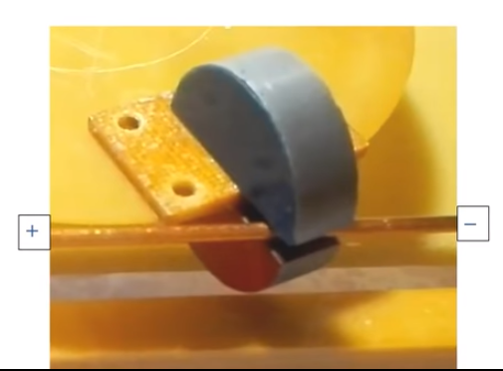

Surprisingly, the simpler the experience, the more views he has. Serious work, on the contrary, does not deserve the attention of the general public. For a year this video has scored the greatest number of views in comparison with other my works – more than 72 thousand. But this joy is not enough. So far there is no understanding of the essence of this experience. This can be explained only by the fact that people are content with theorizing (shifting in the head of what their teachers have put there), are lazy to set the experience and independently check its results.
It is unfortunate, but some people can not understand the essence of what is happening right in front of their eyes, despite the hints that I posted in the comments to the video. Some visitors do not want to understand anything, calling the author, thinking that in this way will compel him to make excuses and begin to explain, what exactly is the salt of the shown experience.
Reading the comments to the video, left by the visitors of the channel, you wonder how low the mores of modern youth. In the address to people it became usual rudeness, foul language, disrespect not that to the contemporaries, but even to the elderly person. How can you trust the mysteries of the universe to such ignorant and embittered people who, as thieves, scour the internet in search of ready circuits and technologies? Give it to the "freelers" of the BTG, they're the first to lose you. For this reason, from now on, I will cover some of the information in my videos in order to protect normal people from possible attacks of "beasts" in human form, armed with new knowledge and technologies. Those who will think on their own, sooner or later, with patience and work, necessarily reach an understanding, and will be able to find a way to repeat the necessary experiments.
Among the comments, some visitors to the channel receive advice to the author of the movie "Teach Physics". That's the kind of clever I highly recommend to watch this video. Let them find in their textbooks the answer to the question: "Why is the lamp lit?".
And to all adequate people I speak, I give the word of honor, that in the offered to your attention experience there is no cheet, deception and hidden wires. Everything is actually happening as you can see on the screen. Think, develop, learn to think independently. I wish you a pleasant viewing.

For those who wish to support the project:
Map of Sberbank 2202 2003 1798 8028
Yandex Wallet: 410016577268165

2. Elements of Experience

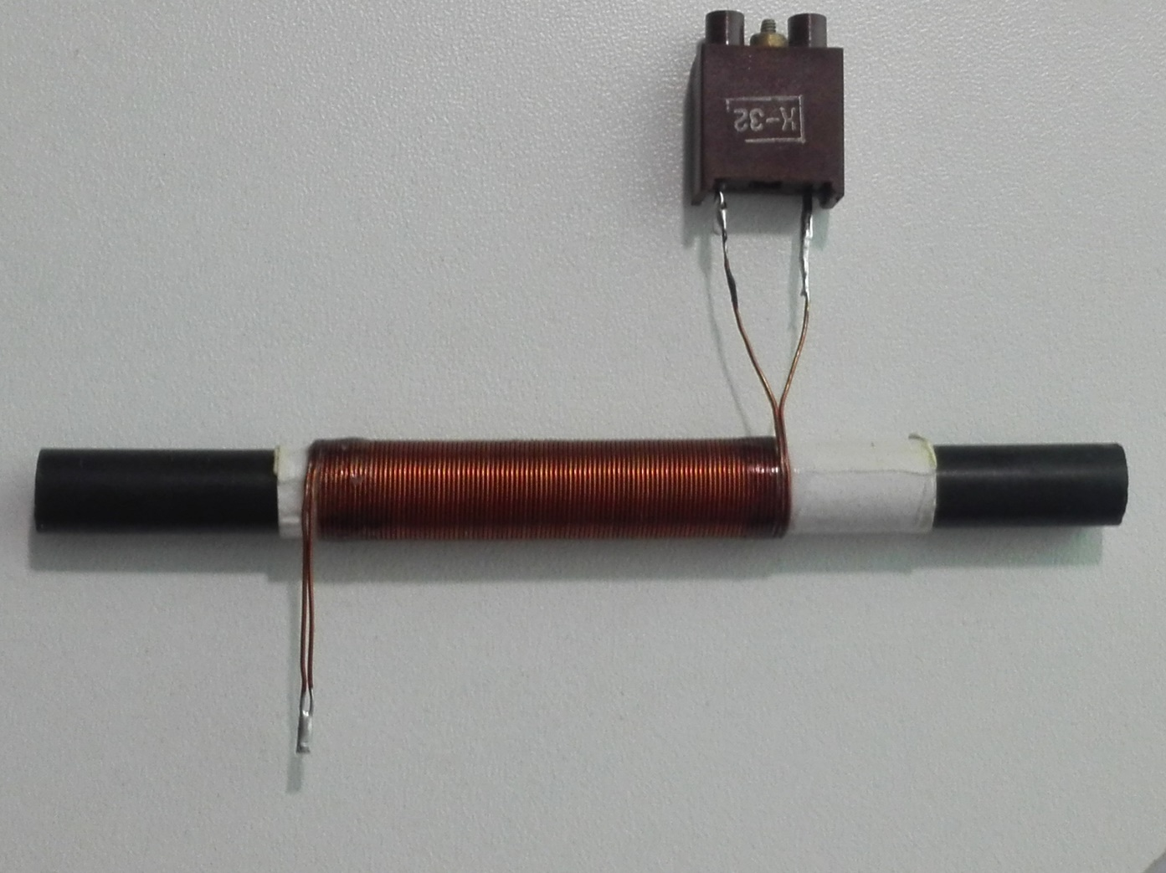
1) The coil is wound on the paper sleeve in two wires by copper wire in the enamel insulation, which is a bifilar or non-inductive coil. As the core of the coil is used ferrite rod Mark 400 LV (from magnetic antennas transistor radios). It is clear that the inductance of the bifilar coil is almost equal to zero. Accordingly, and EMF of such coil is also equal to zero. Everything else is well seen in the photo.
The diameter of the wire and the number of coils is not of much importance here. On one side of the coil two outputs are connected together, and on the other side of the coil to two conclusions will connect different load.
In the experience the coil lies on top of the inductor, the design of which is intentionally (as I promised) covered with paper. As a hint I will only say that on my channel in one of the rollers I have already applied this kind of inductor. Below on an oscilloscope I show the form of the signal from the generator (the bottom trace) which, being strengthened by a power switch, arrives on the inductor. The photo shows the falling edge of the rectangular pulse, the front part is not visible in the screen.

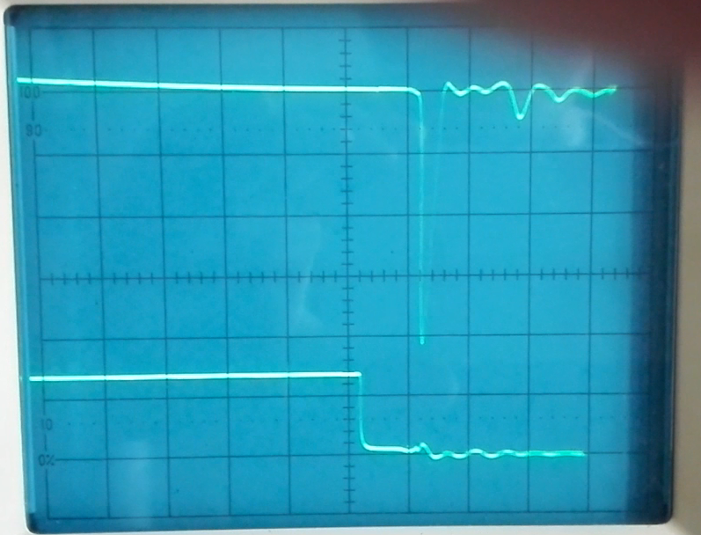
The upper trace shows the shape of the magnetic impulse. Pulse duration is 500 ns. The impulse is formed after a slight delay following the falling edge of the pulse from the generator.

3. Load – Incandescent lamp

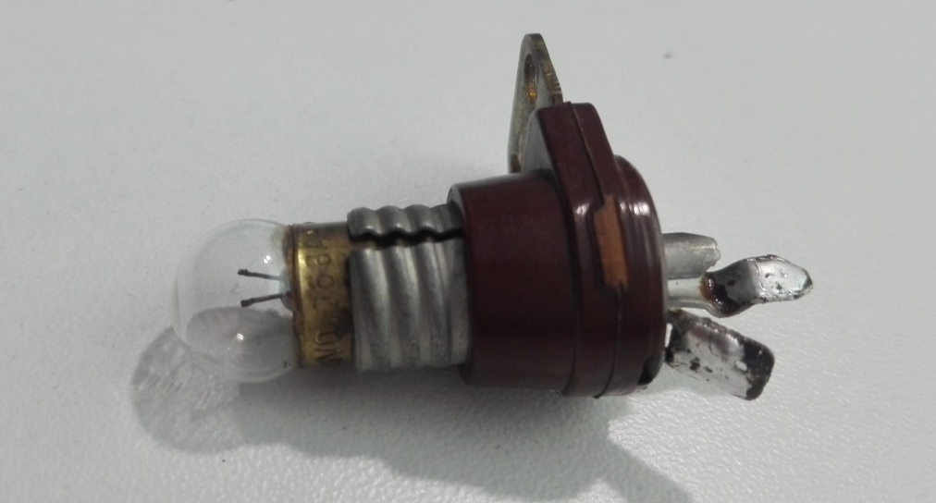

4. Load – LED array
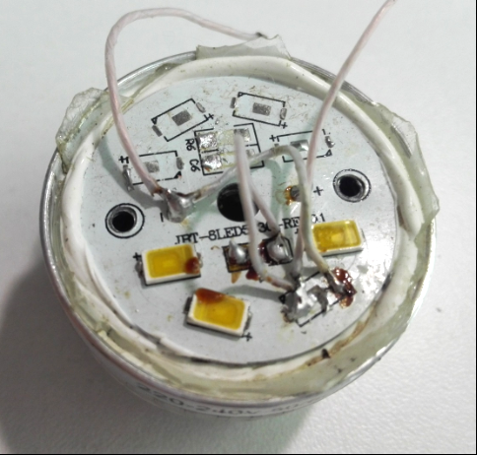

5. Load – motor with fan
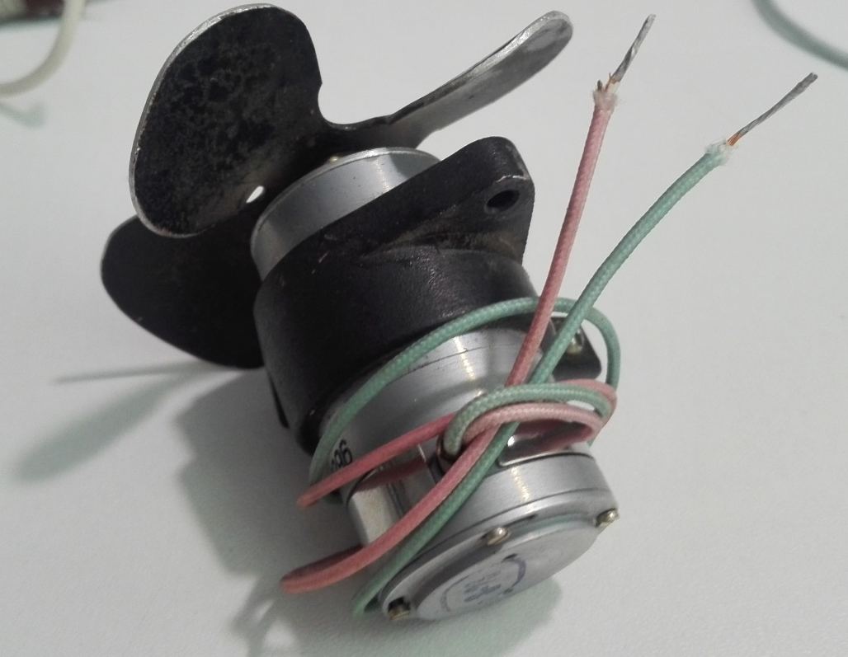
Watch the video fragment:

6. Result of experience

As a result of experience all three loads were worked – active load in the form of incandescent lamp, led matrix and active load as a collector engine. I did not specifically stop at all aspects of this experience and did not show the other interesting features that this experience is overflowing with. All this becomes possible if there are moving electric charges, but what are they?
In light of the above, it is clear that this experience deserves the utmost attention.
I think that in any textbook it is impossible to find explanations to that on the non-inductive (Bifiliar) coil It would be possible to receive EMF. The fact that there is no explanation indicates that there is no basis, the concept of physical environment. Why it is so? make your own conclusion. Therefore, those who wonder why I shoot long videos about the air, trying to formulate the properties of the world environment should understand that for normal constructive thinking is just as necessary tool, as for wrapping the screw, unscrew the nut and so Next. And without the concept of the world environment such a tool cannot exist.
It is offered a variant of explanation of experience, according to which there are not one species, and two types of electric charges-positive and negative. In this coil it becomes possible to separate charges and directed their movement.
Bypassing all the details, I will say that you can create conditions under which you can get free positive charges, the properties of which in terms of logic could be called dual in relation to the properties of negative charges. You will not find these properties of positive charges either in textbooks or in encyclopedias. They can only be obtained by a logical transformation method. But, unfortunately, modern logic instead of three operations-inversion, blowing and supplementing teaches only one operation of inverting.
On the other two operations, the logic keeps a complete silence. Therefore, people do not have the stereotypes of thinking (tools) they need. As a result of this people do not distinguish the properties, qualities, physical phenomena with which they face every day. For the same reason, they cannot independently articulate the physical properties of the various electric charges. For example, think about the meaning of the following three phrases:
1) be a boon;
2) not be a boon;
3) be not a boon.
They all mean something specific and cannot be substituted for each other. Do you feel how unusual and difficult it is to catch their meaning?
I'll give you another example. What do the words mean:
1) Lie;
2) not true;
3) the Krida;
4) Deception.
I am sure that most will say that these words mean the same thing and are wrong. All these words mean completely different things. This is (inability to discern), friends are the result of our ignorance. Note that color blindness does not correctly distinguish colors, and not able to perform logical operations does not see differences in concepts. If we do not see the difference between the four words above, we will not be able to discern the concepts (unnoticed) in other areas of human activity. After all, we will reach the stage of degradation, when the main term of our communication is the word "KU" in different intonation, as in the famous Soviet film "Kin-dose-dose".

Therefore, it will be our slogan-"Learn, learn and learn again", otherwise we do not stop the already launched process of social degradation.

