KACHER technology
Brovin V.I., Machkin P.I.
This article contains the full version of the report, the talking points of which were presented in the
organizing committee of the fourteenth international conference: "Security management issues
20 December 2006 in Moscow, at the Institute of Management Problems
Russian Academy of Sciences (IPU RAS), and published in the writings of this conference.
This article looks at the essence, purpose, purpose, objectives, and application of the new
domestic integrated technology, based on a new physical phenomenon
by contactless transmission of inductivity energy through magnetic moments of atoms
substances located in the space surrounding the energy source, open,
explored, described by the author of this discovery, Browin V.I.
[7, 8].
On the basis of this new physical phenomenon, it is possible to create a new one in its physical
the properties and functionality of the device (which the author called a kacher, -
and which (the quality) in the physical form of its construction can
Be implemented in the form:
- Transistor Control Devices (Kacher-UT)
- Absolute sensor (kacher-AD)
- DC transformer (kacher-TPT)
Electric field generator (kacher-GEO)
and as a new way to transmit information implemented as a device
inductive transmission of information (kacher-SPI)
The material of the article, in order to facilitate its presentation and simplify the perception of readers,
divided into separate sections that address different aspects of this new
physical phenomenon and its application in the construction of various devices and products:
1) Swing and kacher-process;
2) Transistor Control Device (Kacher-UT);
3) absolute sensor (kacher-AD);
4) DC transformer (kacher-TPT);
5) electric field generator (kacher-GEO);
6) inductive transmission of information (cacher-SPI);
7) KACHER technology;
8) Conclusion.
And because on the basis of this new physical phenomenon, different
new devices and products with new features and features
very useful in various areas of human activity, then at the end of this article
the authors invite all those interested in cooperation and cooperation on joint
develop these new devices and products, for their subsequent broad practical
use, and indicate their coordinates for this.
1. Kacher and Kacher Process
What is common to all of these devices, which combines them with each other, is the kacher process,
which refers to the process of periodic formation of short pulses of current with
amplitude in hundreds of amps and duration in nanoseconds. Using the same process
to produce different functional characteristics, allows you to create different
its functionality and purpose of the device: kacher-ut, kacher-AD,
TPT, kacher-GEO and Kacher-IPI. Kacher, in the most general and simple way of constructing it, consists of two parts,
galvanically unrelated (see Figure 1 and Figure 2):
- Inductor, which is a coil (e.g., sizes 15 to 45 mm) of two
inductivity (L1 - 1st inductivity, which A - the beginning, and B - the end of the coil; L2 - 2nd
Inductivity, which B - the beginning, and G - the end of the coil - see rice. 1.a) connected in
VT (L1) electrical circuits into the collection chain and L2 in the base chain
transistor) in mutually opposite directions, so that the end of the B
L1 inductivity was connected to the transistor's collector, and its beginning A, along with the end of G
L2 inductivity were connected to the "z" power source, and the beginning of B of this inductivity
was connected to the base of the transistor (see pic. 2.a);
- receiver, which is a coil of inductivity L3, which D - the beginning, and E -
end of the coil, - see pic. 1.b), connected sequentially with a detector (VD diode) and
RC-chain (parallel to the connected smoothing capacity C and load
resistance to Rn) in the secondary electrical circuit of this device (see pic. 2.b).
Thus, the inductor is the primary chain of the kacher, and the receiver is
Secondary.
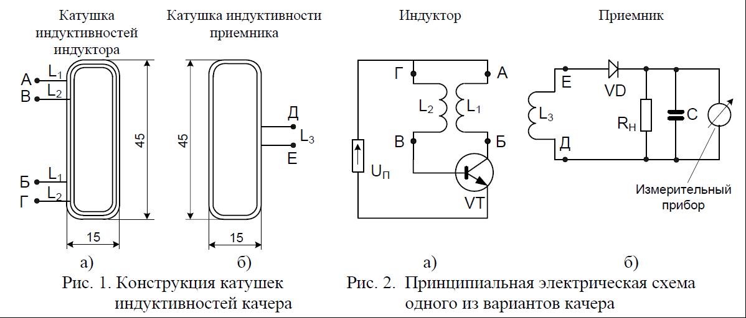
Let's consider the practical implementation of the kacher in the form of a transistor control device
(kacher-UT), and we will conduct a detailed analysis of the processes that are going on in it to uncover and
descriptions of the inner essence of the kacher process, which is the basis of the functioning of all
the rest of the devices above, built on its base. Principled
The electric scheme of the kacher-UT is presented on rice. 3, in three versions of its practical
Implementation: on rice. 3.a - when the offset source is incorporated into the base chain of the transistor,
Fig. 3.b - if inductivity is consistently incorporated into the base chain of the transistor,
Fig. 3.v - when inductivity is included in the base chain of the transistor.
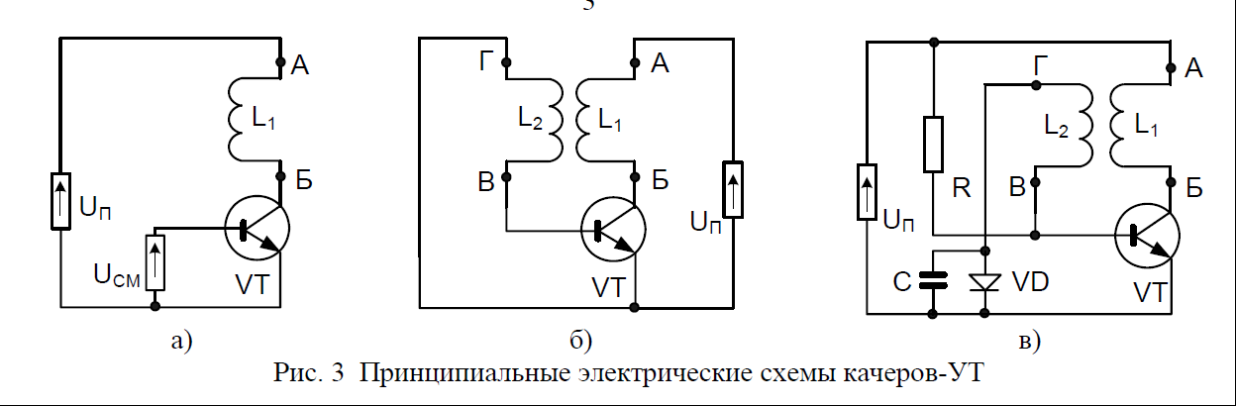
Fig. 3 Principled electric schemes of kachers-UT
The essence of the implementation of the kacher in the form of a kacher-UT is the ability to implement in a chain
inductor of the kacher-process. This is achieved by the fact that the inductivity in the
transistor's collection chain, there is a self-induction EMF, which acts as a
the carrier's removal blocker from the base through the collector, thus ensuring the accumulation of
the main number of media in the transistor base for some time
Interval. This accumulation occurs as long as the internal potential of the base is not
equals the potential of a offset source in the base chain of the transistor. When
These potentials are short-circuited
through the galvanic link of the collector-emitter and located in the collection chain
transistor inductivity, which (short-circuit) is accompanied by a takeaway
accumulated carriers from the base under the influence of the electric field of the source
supply in the transistor's sewer chain. At the same time, the amplitude and the duration of the current pulse
short circuits are determined by the number of media accumulated in the base of the transistor and
resistance to the short circuit. And since the omic resistance
inductivity, located in this chain, very little, then the impulses of the current will have
amplitude of about hundreds of amps and duration - a few nanoseconds.
Let's take a closer look at the processes that are going on in the inductor of the kacher-UT (graphic representation of which is shown in the pic. 4), when implemented according to the scheme given on the Fig. 3.
If the transistor in this scheme is left locked (with the help of a source
displacement in its base chain), with the amount of voltage at the base below
unlocking voltage (e.g., U.0.5 B), then through the collection-emitter transition will be
go on the escalating current (I'ik, see pic 4). The increment of current causes EMF self-induction,
which is deducted from the power voltage: Uk - E < Ub. Numerically, roughly, it's
looks like this: U.S. 30 B, Uk 0.1 B, and Ub 0.5 B (Uke voltage, Ube on Figure 4). As a result,
the collector's electrode in the pause is under less potential than the base electrode. And
because the transistor collector area is usually less doped than the emitter,
therefore, the media are drawn to the base transition under the influence of a larger
the potential of the base electrode. The low potential of the collector blocks the main takeaway
media through the collector. At the same time, the current of the base decreases (current Ib on Figure 4), as
with the advent of carriers in the volume of the base, its internal capacity
to meet the tension of the external source of displacement. The current base in the swing on its physical nature is a compensatory source, formed by two sources of nutrition: the source of
shifts in the base chain of the transistor and increasing in the implementation of the kacher process the base's internal capacity. If the current is equal to zero, the potentials of the source of displacement and the internal capacity of the base is being compared, allowing the potential
barrier in the collector. Following the break-in of this barrier, there is a short-circuit
(accompanied, as mentioned above, by removing media from the base) through the
collector-emitting transition and collector's inductivity, with very little omic
resistance to the whole chain (about 0.1 Om). This means that the current in the pulse of the short the closure will be about 300 A.
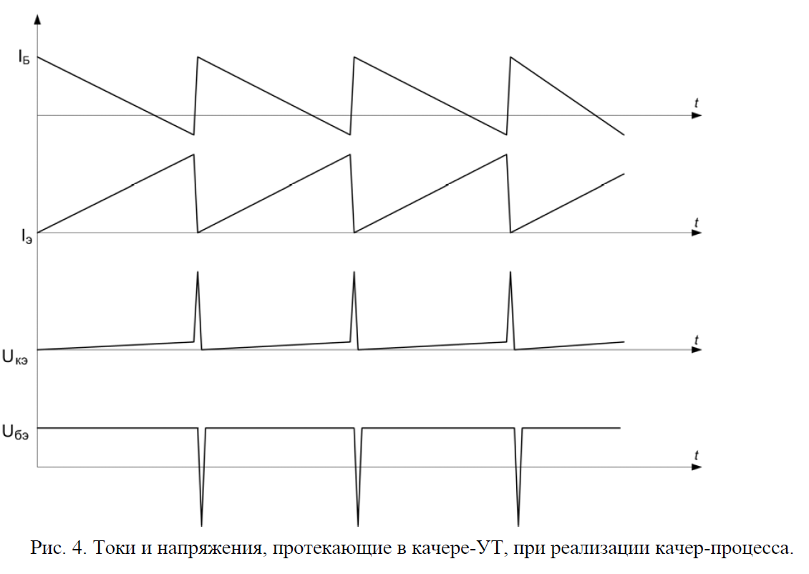Fig. 4. Currents and voltages flowing in the kacher-UT, when implementing the kacher-process.
And the magnetic field of short-circuit current (with an amplitude of about hundreds of amps and duration - one nanosecond) makes a mechanical turn of magnetic moments
atoms of ambient matter (similar to how it occurs in a nuclear magnetic
resonance with the selection of energy from the power source). And so the current that gave the energy of its magnetic field, can not be seen in the form of a drop of voltage on a small resistor.
But this virtual current explains the formation of highly amplitude pulses
immutable polarity relative to the reservoir's power pole (since
they are measured from different angles, relative to a virtual current that has one
direction).
It should be noted that the kacher-UT, collected according to the scheme given on the rice. 3.a, is very sensitive to any external influence, so that, for example, any touch of measuring devices causes distortions in its work. But, nevertheless, this kacher-UT scheme operates in a wide range of boundary conditions by magnitude inductivity, transistor types and power voltage.
But if the same in this scheme in the base chain of the transistor along with the source of displacement put inductivity (you can either serial - as on rice. 3.b, or parallel -
It's like rice. 3.c), then this scheme of kacher-UT begins to work steadily, and becomes
insensitive to the external influences of different fields and radiations. Touch
probe of oscillograph or other measuring devices does not lead to distortions
scheme work. Forms of currents and voltages when working such a scheme are shown on rice. 4, they are similar to the scheme indicated in the rice. 3,a, but are more resilient. Currents and
the voltages of the kacher-ut are sharply different in shape and sign. Voltage impulses can
be tens of times the voltage of the power source, and it does not correspond to the current. This shows that only EMF self-induction works in the kacher-UT scheme.
The result leads to the following conclusion: the origin of self-induction is
and there is a selection of current energy to rotate the magnetic moments of the atoms of the surrounding matter, and their return to its original state when the chain is disconnected from the voltage source.
The peculiarities of the kacher-process implementation are characterized by the fact that, first of all, in this how this device works only within the EMF self-induction, which occurs on inductivity, and does not go into the well-known stationary transistor mode, and secondly, in this mode, it does not cause voltage, but the current
thirdly, this regime does not respect such basic, fundamental laws of physics, like the laws of Coulomb, Amper, and Kirchhoff, and, fourthly, current and voltage in this mode operate in opposite directions, - in full according to Maxwell's equation for EDS self-induction.
It should be stressed that short impulses should be obtained in the usual way
it is impossible to generate and dissolve media because it takes time to generate and dissolve media substantially more than the instant takeaway already pre-accumulated.
The pulses of the current in this device are hundreds of amps and durations in the
nanoseconds, have many useful, previously unknown physical properties, such as
for example, how to transmit information through solid environments (previously insurmountable, for example, such as: liquids, metals, dielectrics), because the energy of the current of such a pulse goes to the
mechanical rotation of magnetic moments of atoms surrounding the source of energy of matter. As to the areas where the device is possible to be used,
note that: (a) The kacher-UT can control transistors and tyriors of any power on the
transformer connections, so the use of these devices will make it possible to make
contactless and non-inertial widely used in practice in various fields
human activity relays, magnetic triggers, potentiometers and restats;
b) Kacher-UT will make contactless connectors different from the fact that in the secondary
chain will be a full-fledged electrical signal, which makes it no longer necessary
installing an additional power source in this chain is very necessary, for example,
for laptops, cell phones, separate parts of robots, collectionless
electric motors, etc.
Let's take a closer look at the other forms of practical implementation of the kacher.
3. Absolute sensor (kacher-AD)
If a voltmeter is connected to the receiver when a working inductor is connected to the receiver,
considerable voltage, in tens of volts, at distances from millimetres to centimeters from
inductor, falling linearly from a distance (see figure 5).
This property of the kacher allows you to build it in the form of an absolute sensor - kacher-AD.
Therefore, the essence of the implementation of the kacher-AD is the possibility of linear transformation
non-electric values (reflecting the parameters of moving something relatively
any given point of space captured by such a sensor and
expressed in linear sizes: meters or degrees), - in electrical values
(expressed in volts, amps or hertz). This is achieved through a consistent
compounds in the secondary chain of a conventional diode and capacitor. At the exit of the capacitor the impulses of the unipolar current, the parameters of which can be expressed
linear dependence in volts, amps or hertz
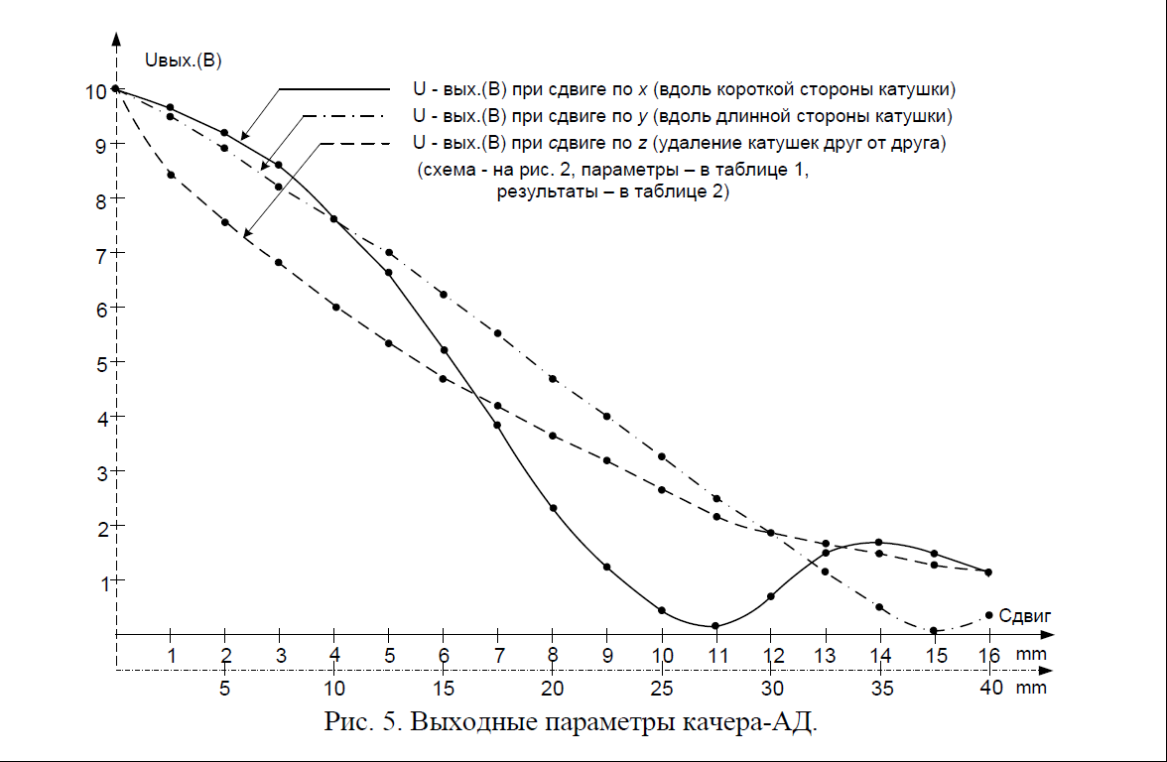
Fig. 5. Weekend kacher-AD options.
Presented on rice. 5 characteristics of linear voltage dependence of U.S.B.
Receiver kacher-AD from its distance to the inductor:
- when moving the receiver inductivity coil along the short side of the coils
inductivity of the inductor, i.e. the shift of the receiver to the right or left relatively
Inductor's plane, by coordinate X;
- when moving the receiver induction coil along the long side of the coils
inductivity of the inductor, i.e. the receiver shift up or down relative to the plane
Inductor, - by coordinate Y;
- when the receiver's inductivity coil is removed up or down relative to the plane
inductor inductivity coils, - by coordinates;
obtained for the kacher-AD scheme shown in the rice. 2.a, with the parameters of its elements,
presented in the table. 1.
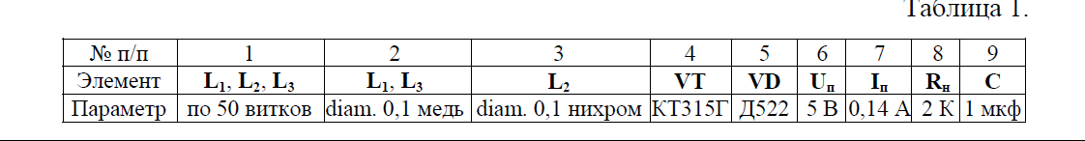
At the same time, the number of output values of the U.S.B.
these parameters are given in the table. 2.
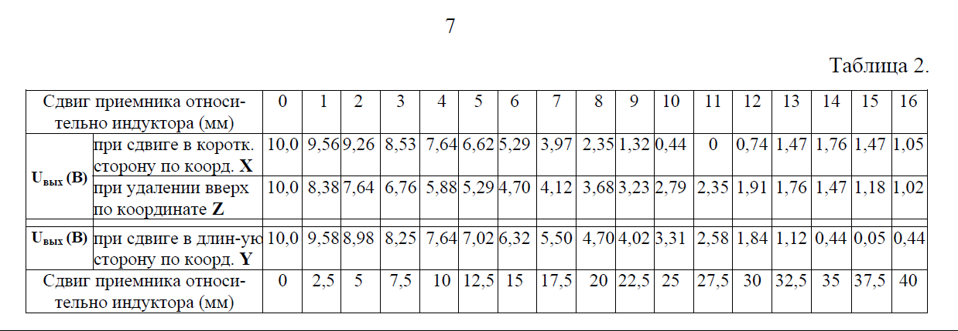
4. DC Transformer (Kacher-TPT)
The essence of the implementation of the kacher in the form of a DC transformer (kacher-TPT)
is the possibility of raising (or lowering) the secondary chain of current and
Voltage. This is achieved by the fact that when you implement a kacher-process in the chamber,
the unipolar impulses of the high-amplitude current formed by him in the inductor cause
formation in the receiver (inductivity of the secondary chain of the kacher) is also unipolar
pulses of current. If these unipolar current pulses received are "drained" into the container,
as a result, we get a constant current. The device that implements this process is inherently and
is a DC transformer. At the same time, the work of this transformer on the
increase or decrease in current and voltage is provided by the required ratio of the number of
inductivity included in the primary and secondary chains of the kacher. If the number
there are more induction in the secondary chain in the inductivity of the primary chain
the transformer increases the current and voltage, if less - lowers. When
placement of the same ferromagnetic core between inductivity included in the
primary and secondary kacher chains, you can increase the power of the kacher-TPT. At the same time,
ferromagnetic core when implementing the kacher process is not complete
tipping the domain, and only its so-called "nod" nanosecond duration.
The principal electric scheme of the kacher-TPT, using ferromagnetic
core between inductivity included in his primary and secondary chains,
presented on rice. 6, in two versions of its practical implementation: on rice. 6.a - Kacher-TPT
for reduced power voltage values of U.S. less than 0.1 B, and on rice. 6.b - Kacher-TPT for
power levels within 0.4 - 0.6 B.
Regarding the areas where kacher-TTP devices can be used,
note that they can work steadily against ultra-low power stresses. Installed
and it is virtually confirmed that it is possible to achieve a sustainable implementation of the kacher-process from
On the basis of this, it can be argued that the quality of the
TTP can steadily convert 0.1 B to 1 B, which in turn determines
the ability to use it highly effectively to convert it to a permanent current
energy generated, for example, by a thermopa or solar battery. The use of the same kacher
TPT in conjunction with the solar battery to transform solar energy into a permanent
electric current (see Figure 7) will also significantly improve the reliability and
efficiency of solar panels due to the possibility (thanks to
functional characteristics of the kacher-TPT) parallel connecting individual of them
modules (compared to the diagram of their sequential connection in normal mode).
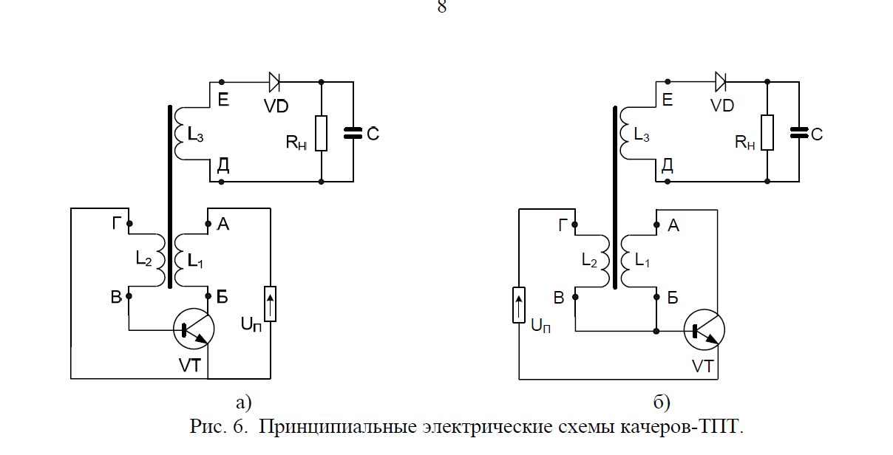
Fig. 6. Principled electric schemes of kachers-TPT.
In addition, kacher-TTP devices can also be used to convert
to the constant current of any "unstable electrical debris" that is possible to obtain and
transformation, for example, from wind energy, sea excitement, etc.
manifestations not yet adapted by man to any practical
Use. The electric high-amplitudes formed at the exit of such a device
pulses can be accumulated in known devices (e.g., "drained" into a container) with
receiving a DC for later use in practice in
different purposes.
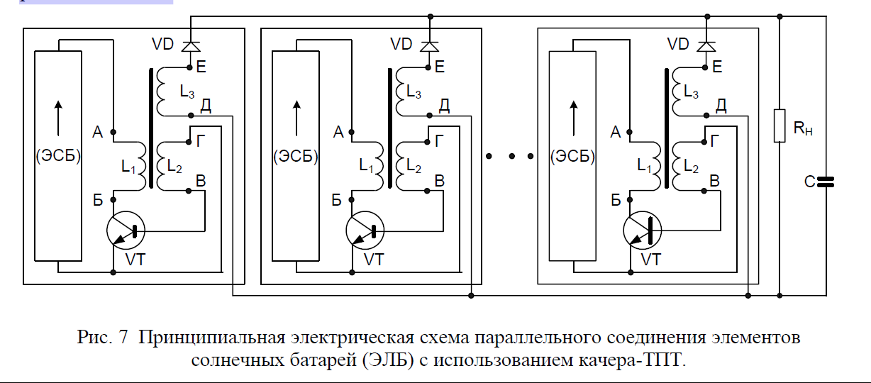
Fig. 7 Principled electrical scheme of parallel connection of elements
solar panels (ELB) using kacher-TPT.
5. Electric Field Generator (Kacher-GEO)
The essence of the implementation of the kacher in the form of an electric field generator (kacher-GEO) is
the possibility of practical implementation in the basic chain of the transistor mode "transformer Tesla" is designed, as it is known, to generate pulses of the electric field.
This is achieved by severing the galvanic link of the base transistor chain (withinductivity included in this chain). And when it flows in the chain, the emitter collector
transistor of the kacher process, due to the transformer communication of inductivity included in the
the base and collector chain of the transistor, on the at-open base chain of the transistor (on the
inductivity, included in this chain) are formed pulses of the electric field.
This generator is currently in various literary sources (e.g. in the "10")
called the Tesla-Brovin generator.
Tesla Transformer and Cacer-GEP's main electrical schemes (or
"Tesla-Brovin generator") are presented in rice. 8: on rice. 8.a - "Tesla Transformer" and on
pic 8.b and 8.in - "Tesla-Brovin generator", in two variants of its practical implementation, on
Fig. 8.b - kacher-GEO on a transistor, without the use of a ferromagnetic core, and on the
Fig. 8.v - kacher-GEO on a transistor, using a ferromagnetic core, between
induction included in the primary and secondary chains of the kacher. At the same time,
implementation in this cacher-process generator, by breaking the galvanic link in the chains
with L2 induction (in the rice version. 8.b) and L3 (in the rice version. 8.in), at the ends of these
inductivity is formed pulses of the electric field.
To determine the areas where kacher-GEO devices can be used,
first, to note the features of the construction and operation of the "Tesla Transformer" and
"Tesla-Brovin generator" and then their differences with each other.
Tesla Transformer is a high voltage device
high frequency. In the most elementary, simplest form, this device can
to be presented in the form depicted in the pic. 8.a. It consists of two L1 coils -
primary and L2 - secondary, capacitor C, power source and discharger. L1 coil
built from several turns of large-diameter copper insulated wire, and L2 from
many turns of copper insulated wire are much smaller in diameter. Unlike
there are no ferromagnetic nucleus or core transformers here, and so
The induction between these two coils is small.
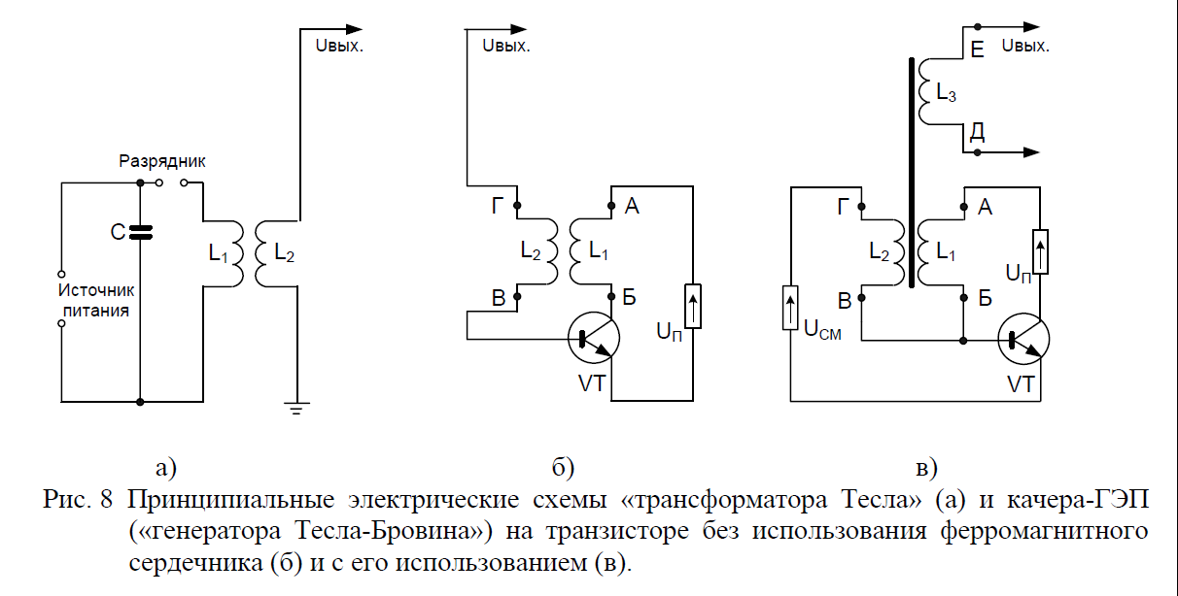
Fig. 8 Tesla Transformer (a) and CACER-GEO
("Tesla-Brovin generator") on a transistor without the use of ferromagnetic
core (b) and using it (in).
In the primary chain, a capacitor is charged from a power source. When
the electrical potential accumulating on the capacitor becomes equal potential
breakdown of the spark gap of the discharger, then there is a breakdown of air between the electrodes
discharger, so that capacitor C and the primary L1 coil become bound
between themselves in a consistent RLC chain through which the powerful begins to flow
pulse current, creating electrical oscillations in the chain of electrical oscillations of a certain
frequencies.
Electrical oscillations in the primary L1 coil due to voltage induction
transferred to the L2 secondary coil that forms its RLC chain. At the same time, the parameters
electrical oscillations of these chains are determined by their structural parameters.
Thus, it can be noted that the "Tesla transformer" constructively represents
a vibrational circuit included in the primary winding of the transformer, and a secondary
the winding is in an open state no matter what is loaded, and when flowing into the
primary winding of the oscillation process in secondary winding by induction
voltage is imposed by the EMF.
By selecting the structural parameters of these chains to achieve resonance (coincidence) of frequencies
electrical oscillations in the secondary circuit frequency of electrical energy fluctuations in the
the primary chain of this device reaches a high voltage (up to 7 to 106 B) of high vibrations
(up to 1.5 to 105 Hz) frequencies.
As shown in the "14" voltage, this resonance voltage is capable of creating
impressive electrical discharges in the air, which can be many meters long,
as well as other phenomena. So, for example, Tesla's transformer
was used to generate and disseminate electrical oscillations aimed at
Wireless devices (tele-control), wireless communication
(radio), and the wireless transfer of energy that was all achieved by him. In the beginning
"Tesla Transformer" has also found popular use in medicine.
Patients were treated with high-frequency toss capable of passing through without harm
human body, while having a tonic and healing effect. However
studies of the effects of HF currents on the living organism conducted in recent years
years, have shown the negativity of their effect on the nervous system. At the same large enough
current power in the blood vessels is formed by micro-clots, which can lead to
blood clots Get such a high performance in this device
15, - experimentally proved that the "Tesla transformer" conversion rate
always 10 to 50 times higher than the ratio of the number of turns of secondary winding to the number of turns
The primary winding is achieved by the resonance achieved when the match is
frequency of electrical oscillations in the secondary RLC circuit of the transformer with one of the frequencies
oscillations from the huge spectrum of frequencies formed during the discharge in the spark
interval in the primary RLC-chain of the transformer.
But the physics of the processes going on in the Tesla "transformer" remains in many ways
mysterious, mysterious and incomprehensible. Classical physics fails to explain
Tesla Transformer action. A theory that somehow explains the processes that take place in the
The Tesla transformer is not known to modern science. This theory was certainly at the very
Nicolo Tesla (undoubtedly the most mysterious scholar of the 20th century)
described and explained all his innovations, experiments and results. But she broke up with
classical physics and now refers to modern science as an alternative
physics that recognizes the ether as a real medium.
The main feature of the "Tesla transformer" is that on a free electrode
secondary winding emerges a field similar to an electric one, with some still not known to modern science properties (the physical nature of which it simply does not
to further fundamental study and
Understanding. Preliminary analysis of these properties shows that they can be based on formed entirely new, not yet understood and not explored by the modern
science of the idea of electricity and the possibilities of their further practical
Use. In support of these words, the authors of this article invite all
wishing to visit the websites on the Internet listed in the "17" in order to make sure that
This.
Now, based on the results we have received when considering the features of the
tesla's "transformer" is not marked by its differences from the "generator
Tesla-Brovin."
The main difference between the Tesla transformer and the Tesla-Brovin generator is that
that the magnetic field energy accumulating in the inductivity of the Tesla transformer,
periodically discharged between the discharger's electrodes through the air, and in the "Tesla generator-
Brovin"s magnetic field energy, accumulated inductivity of the primary chain of the kacher,
periodically discharged (as part of the process implemented) through the collection
ettercip to the transistor (see figure 8 b). Another important difference is the Tesla generator
The "Tesla Transformer" is the ability to control the oscillating swing
process in the secondary transistor chain, by connecting one of the ends
L2 inductivity to the transistor base (as, for example, this is implemented in the scheme presented
On figure 8.b; in the scheme of the same kacher, equipped for greater efficiency ferromagnetic
core, presented in rice 8.v, secondary winding of the generator with transistor
galvanically unrelated). What is common to them is that, one of the poles of the secondary
high-voltage winding "Tesla transformer" and "Tesla-Brovin generator"
galvanically unrelated to anything Considered features of the construction and operation of the kacher-GEO (generator
Tesla-Brovina") and its differences from the "Tesla Transformer" allow us to define the areas of its
possible use. As of which, for example, they may be named:
(a) Substance property analyzers;
b) Electrical field transmission devices;
(c) Detectors reacting to the approach of the electric dipole;
d) devices that transmit and receive electrical energy on one wire
(and, not on two wires, as in all existing now and widely
used in practice, different devices for transmission and reception of electrical energy, -
And one wire at a time);
(d) Devices that shine fluorescent lamps (daylight lamps) of any
capacity and any type of size without any source of significant
the electrical energy of the luminophore in them begins to glow under the influence of radiation,
The swinger created at the same time, the energy required to create radiation by the
will be much smaller than the current methods; now, as we know, for
ensuring the glow of fluorescent lamps is used by a significant electrical
energy of at least 220 B, and special electrical devices in the form of throttles and
Starters
Devices that shine LEDs of any power and of all sizes
much less energy required for this (compared to the energy currently used
the energy of their lighting under the existing modes of their functioning);
(f) Inductive transmission devices between different objects
For example, traffic lights located on opposite sides of the intersection and entering the
composition of one traffic light object, but without the use of this currently used
The time of electrical wires being laid between these traffic lights(c) Devices to accelerate chemical reactions to separate any
initial chemical compounds for constituent components, as well as the synthesis of new
Compounds not formed in conventional (current) technologies;
and) as well as many, many other areas of possible practical use of
Gap.
6. Inductive transmission device (kacher-FIP)
The essence of the implementation of the kacher in the form of a new information transmission device (kacher-IPI)
is the possibility of inductive transmission of information through solid environments, previously
irresistible (liquids, metals, dielectrics). This is achieved through practical
implementation by the transmitter (kacher-IPI) of the kacher-process that leads to the turn of the magnetic
moments of atoms of matter in the ambient source of information space,
using a transmitting inductor (which is part of the transmitter) and receiving the results
turning magnetic moments of the atoms of this substance by the receiving inductor. This way
inductive transmission of information is inherently a new, sixth way of transmitting
information (in addition to the known to date and widely used by humans
five physical ways of transmitting information through: sound, light, electric
electromagnetic waves and pneumatics).
The basic electric scheme of the kacher-IPI is presented on rice. 9 and 10, in three
options for its practical implementation: on rice. 9.a - a kacher for transmitting information through
solid solid environments (such as earth, stone, brick, concrete, wood, etc.)
through an electric field, on rice. 9.b - a mixer for transmitting information through liquid
solid environments (such as water, chemical solutions, mixtures, etc.) through magnetic
fields, and on rice. 10 - a kacher for inductive transmission of information on lighting and force
wires that are energized and electrocuted, and as low-voltage (up to 1000 B),
and high voltage (over 1000 B) wires.
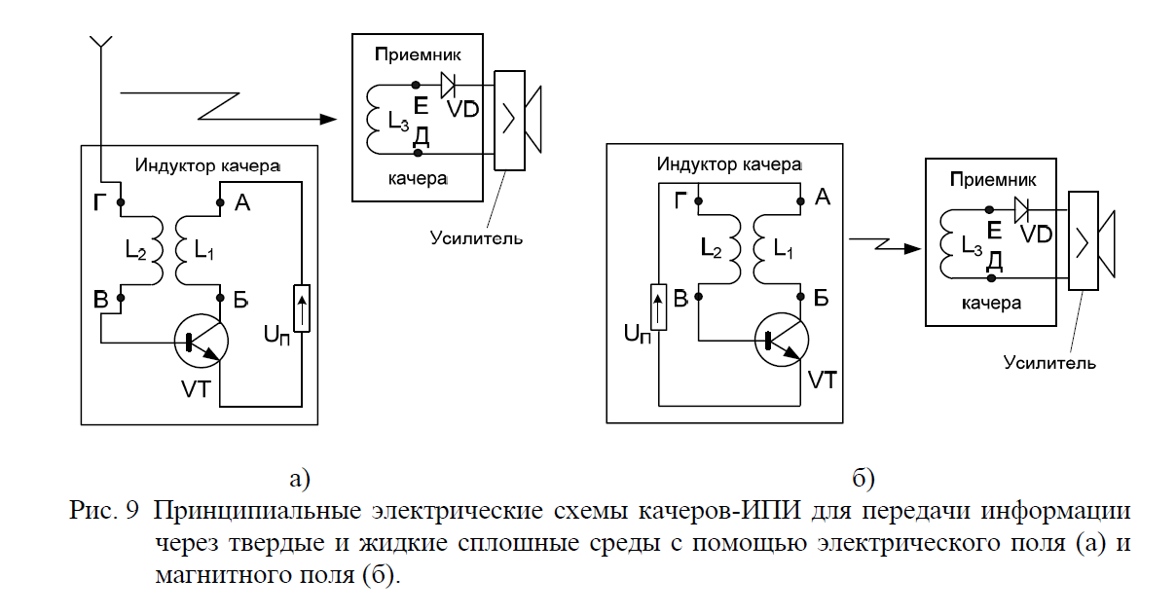
Fig. 9 Principled electric schemes of swing-IPI for the transfer of information
through solid and liquid solid environments using an electric field (a) and
magnetic field (b).
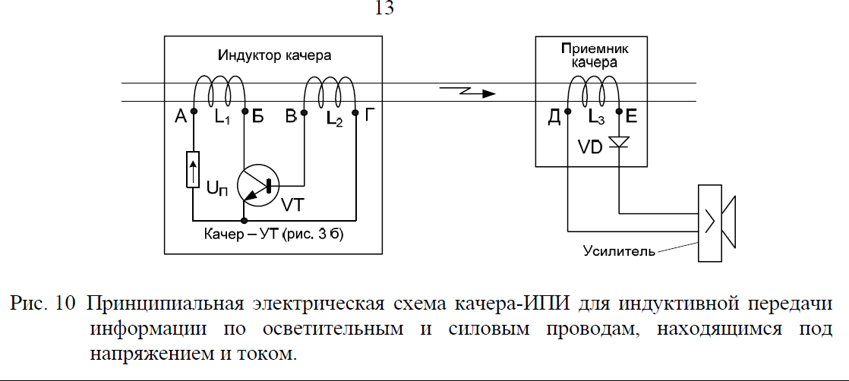
Fig. 10 Principled electric scheme kacher-IPI for inductive transmission
information on lighting and power wires under the
voltage and current.
Regarding the areas where cacher-FPI devices can be used,
note that they are able to transmit information to subscribers through water (e.g.
submarines), or by wires of electrical networks to transmit official
information about the functioning and status of these networks: the flow of parameters, the current
equipment, etc., etc.
In the electrical circuits of the swing there are new, previously unknown properties, but very
useful for practice, through the use of such devices in various fields of science,
technology, communications, computer science, computing, medicine, energy, etc.
any schemes that include a transistor can work in the kacher mode (and it doesn't matter
what type: bipolar, field or radio lamps) and one or two inductivity.
7. KACHER technology
The discovery of a new physical phenomenon under our consideration has led to the creation of new
devices built on its basis and designed to implement new
functions in various areas of human activity. Creating and applying new
devices with new features that are useful for a wide range of
practical use will inevitably lead to the emergence of an industry
production and application, designed in the form of technology that can be rightfully available
to be called KACHER technology.
The purpose of KACHER technology. This technology is designed to create and
application in various spheres and areas of human life
new devices and products with new physical properties and
functional characteristics that operate on the basis of an open new
physical phenomenon by contactless transmission of inductive energy and information
by rotating the magnetic moments of the atoms of the substance in the surrounding
source of energy and space information.
This technology will be integrated because it will not include
only its production component for industrial development and mass production
new devices and products, but all the other components of them:
fundamental, exploratory, scientific, technical and applied research of open
new physical phenomenon, the development of new devices and products that function on the
based on this phenomenon, as well as the widespread practical application of these new devices and
products in various fields and areas of human activity.
The goals of KACHER technologies will be:
- a comprehensive study of an open new physical phenomenon on contactless
transfer of inductive energy and information by turning magnetic moments
Atoms of matter located in the surrounding source of energy and information space;
Creating a manufacturing and wide-ranging manufacturing industry
in various areas and areas of human activity of new devices and products,
operating on the basis of an open new physical phenomenon;
THE objectives of KACHER technology to achieve the above-mentioned goals will be:
- fundamental, exploratory, scientific, technical and applied
(as part of the relevant research and research and analysis) on comprehensive analysis and
experimental verification of an open new physical phenomenon, and assessing conditions
to create new devices and products based on this phenomenon for the benefit of their wide-ranging
Practical applications in various fields and areas of human activity;
Exploring new ways to transform and transmit energy and information
possible for practical implementation on the basis of an open new physical phenomenon;
Creating a mathematical apparatus to describe the physical processes occurring in the
Kachers;
- the development of new devices and products of different types and purposes, built on
based on an open new physical phenomenon, and intended for a broad
Practical applications in various fields and areas of human activity;
Development of industrial production and practical applications
devices and products that operate on the basis of an open new physical phenomenon.
The use of KACHER technology in science and industry systems will be determined
areas and areas of possible applications of devices built on the basis of open
a new physical phenomenon. At the same time, it should be noted that the kachers can be used
wherever electrical circuits are used. Examples include the following areas and applications of the new
ways to convert and transfer energy and information that can be applied to practical
implementation based on an open new physical phenomenon, as well as devices and products
KACHER technologies:
is, above all, a new way of transmitting information (inductive transmission
information) that makes wired telephone networks the same way
(by the speed of information) as well as fiber optic, as
inductivity of the wire, which now blocks the pass of information in wired telephone
networks, will be the opposite of an active information-conducting environment (through
short-term ruptures by the chain of inductivity chains);
are new relays and magnetic launchers with galvanically separated
control (weak) and executive (power) electrical circuits
The magnetic launchers currently in use are electromechanical
devices connecting the electrical contact of executive (force) chains through
magnetic reels of relays, controlled by a low-precision electrical circuit; Main
The lack of these devices is the presence of electro-contact and magnetic coils; Use of the same
KACHER technology will allow for a galvanic separation between contacts and
Coils contacts are replaced by PNP and NPN transistor crossings or
and management chains are implemented through the use of
different types of kachers
is a new way of placing and packaging electronics products, with the transition from
the current two coordinates (X, Y) of the location of the elements, at three coordinates
(X, Y, Y) because, when using KACHER technologyelements can be carried out without their galvanic connection with each other, -- at the expense of
Inductive transmission of information through coordinates;
is a new way of transmitting information through solid environments that were previously insurmountable:
liquids, metals, dielectrics (e.g. to communicate with submarines underwater, or
miners in mines underground);
are new means of communication with those buried in snow avalanches when they are searched and rescued;
is a new way of converting non-electric values into electric ones;
are simple and cheap new sensors and devices of various types designed for:
Use in industrial production as a means of automation and
robotic processes that will do all manual labor
inefficient (e.g., sorting household waste into metal, plastics,
paper, etc.);
Contactless safety at work
The possibility of injury;
Special use for the activities of various special services;
are new connectors without the implementation of galvanic contact of the components
(e.g., between the stages of space rockets, between the mechanisms of cars, etc.);
are new detectors of different types designed for use in systems
Security alarms for wired and wireless alerts;
these are new means of managing automatic mechanisms when the use of
electromagnetic waves for this under the conditions of the processes being implemented
Is unacceptable. - these are new devices autoelectronics and avionics in full;
are new devices of different types designed for contactless inclusion
CCTV at all sites, including doors, windows, floors, balconies,
safes, perimeters, counters, etc.;
These are new alarms;
These are new indicators of water level and loose materials;
are new devices of various types designed for non-contact use in
Auto and garage security alarm systems;
are new contactless control devices for water start-up valves in the shower and
The laver;
- these are new technologies in the implementation of computer games (since costumes with sewn into them
Linear and angular motion sensors (kacho-AD) will tear gamers away from
and computer keyboards and immerse the real participants of these games in a virtual
The space of the computer game being implemented);
- etc., etc., - there are many examples of these, as the areas of possible
the use of kachers is multifaceted and almost limitless, just like that of
Transistors.
In addition, an open new physical phenomenon opens up the prospect of the use of
KACHER technologies in science for further knowledge of the properties of matter. For example, with
using KACHER devices and products can be simple
contactless ways and methods to analyze the composition of the substance and its internal
Structure.
It can also be made very clear that, on the basis of this new physical
by the use of KACHER technology devices and products, will be
new ways have been created and new audio and video recording devices have been developed.
New properties in electric fields, similar to those in the
the open new physical phenomenon in magnetic
Fields.
Widespread practical use of new devices and products
based on this new physical phenomenon, will yield a very significant
economic and scientific and technological impact in various fields and areas of human
Activities.
So, for example, if we mention here only four such applications, out of a large number of them,
Above:
(a) New relays and magnetic launchers built on the basis of widespread use
KACHER-technology - something, given the massive use currently used in
industries and the transport of electromechanical magnetic
starters, their replacement with new relays and magnetic launchers with galvanically separated
between managers (weak) and executive (force) electric
will significantly improve the reliability and energy intensity of such
that will reduce energy costs and improve the efficiency of these industries in the
in general, which in aggregate will allow the country's economy to get a very significant
Economic impactb) devices that shine fluorescent lamps (daylight lamps) not from 220 B,
as now, and using KACHER-technology, from the power voltage of 5 to 10 B, - then,
considering the huge number of daylight bulbs currently used in
various manufacturing, administrative, training, banking, cultural and cultural
entertainment and other buildings and structures, immediately visible just a huge
The economic impact of THE use of KACHER-technology products; This requires a special need
emphasize that the use of fluorescent lamps such as fluorescent lamps as a voltage
small amounts, will significantly reduce the level of fire and explosiveness
use of these lamps in explosive and fire-prone premises and facilities
(which we also have a great many in the country);
(c) Devices that provide the ability to not sequential (used in
now) and a parallel connection of individual solar cell cells,
significantly improves the reliability, durability and efficiency of their work - that
given the widest range of solar panel applications, both in space and on Earth,
there is also a significant economic impact from the use of KACHER technology products in
This area of human practice;
d) Injective transmission of control information and energy between
different traffic lights located on opposite sides of the intersection and entering the
the composition of a single traffic light object (without the use currently used for
this electrical wires, with great labor on their laying) -- then, given the
just a huge number of traffic lights are being used now in all cities and
the country's settlements, and the significant economic impact of the use of
KACHER technology products in this very important area of society.
In conclusion, the following should be emphasized.
Creating new technologies based on a described physical phenomenon can Give
Russia has a very significant advantage over other countries because,
having conducted all the necessary studies of this physical phenomenon in the near future and
having developed a wide range of new devices and products that operate on its basis and
designed for wide-ranging practical use in various fields and areas of
Russia can make a new qualitative leap in its
technological development.
Currently, the following information forums on the Internet are taking place
active discussion of the core nature and content of an open new physical
phenomenon, as well as new devices and products that can be built on it:
- on the website of V.Selivanov / Address: www.valselivanov.narod.ru
- on the website of the Physical Institute of the Russian Academy of Sciences www.lebedev.ru / Address
http://phorum.lebedev.ru/viewtopic.php?t=587&postdays=0&postorder=asc&start=0&sid=c85551
a7f5b88e4d9e1e3725f4a4138e
- on the website of MetaSynthesis Corporation / Address: http://www.msynt.ru/
- sciTecLibrary website / Address: http://www.sciteclibrary.ru/cgibin/
yabb/YaBB.cgi?board=physic&action=display&num=1151310189&start=0
- on the website of Vertex Standard Co.LTD in Russia
"ICS" (on the server of Cuban amateur radio) / Address:
http://news.cqham.ru/articles/discussions.phtml?id=618#8159
- on the website "On spatial energy" / Address: http://www.spkristall.narod.ru/
- on the website "For thinking otherwise - Think different" which was not removed from the website "On
spatial energy" / Address: http://87.225.90.34/forum/index.php
Literature
1. Brovin V.I. "KACHER technology and its application in large complex systems" / Vcompilation: Proceedings of the Fourteenth International Conference: "Problems of Governance
Security of Complex Systems," Moscow, IPU RAS, December 2006, (edited by N.I.A.
Archipova and V.V. Kulba), M., RGSU, 627s., p.502-505.
2. Brovin V.I. "The phenomenon of the transmission of energy inductivity through magnetic moments
and its application, M.,
MetaSynthesis, 2003, 20s. / Address of placing an electronic version of this book on
V.I. Brovin's website on the Internet: http://www.valselivanov.narod.ru/2.htm
3. Brovin V.I. "Brovin's sensor. The essence of the case" / V. Selivanov's website on the Internet
www.valselivanov.narod.ru / Address of the article on the site: http://www.valselivanov.narod.ru/s.htm
4. Brovin V.I. "Meet - KACHER: it's not just a new way of managing
transistor, but also a new way of transmitting information, as well as the Absolute Sensor,
and at the same time the DC Transformer" / Address posting the article on the Internet:
(a) http://www.sciteclibrary.ru/cgibin/
yabb/YaBB.cgi?board=physic&action=display&num=1151310189&start=0
b) on the metasynthesis website: http://www.msynt.ru/Docs/Brovin.zip
5. Brovin V.I. "KACHER (reactive swinger) - a new means of automation based on
Brovin's sensor" / V. Selivanov's website on the Internet www.valselivanov.narod.ru / Address
articles on the site: http://www.valselivanov.narod.ru/
6. Brovin V.I. "Relay approach. Technical description" / V. Selivanov's website on the Internet
www.valselivanov.narod.ru/ Address of the article on the site: http://www.valselivanov.narod.ru/
7. Russian Federation Patent on Invention No. 2075726 "Brovin Sensor for Measuring
(RU) / Author - Brovin
Vladimir Ilyich (RU) / Registered in the State Register of Inventions
Russian Federation, 20.03.1997
8. Russian Patent on Invention No. 2265276 "A New Way to Manage
Transistor" / Patent-clouder - Brovin Vladimir Ilyich (RU) / Author - Brovin
Vladimir Ilyich (RU) / Registered in the State Register of Inventions
Russian Federation 27.11.2005

