Features of work MOSFET
and drivers in key mode

Dayna Sergey Alekseevich

The recent movie "registration radiantnoj energy-1 has a comment from the distinguished subscriber my channel- spincom (a):

Hello dear Sergey!
I started to browse the parts needed to assemble the same scheme and found some inconsistency of requirements on performance and polevika what raskachivajushhaja may grant its opto-mikruha and 3120. You claim that you need fast transistor that provided at least 5 ÷ 10 ns, Oh well ...
And here's what it oscillates very slow mikruha-the fastest time of this 500ns or longer! Because here you can explain the high demands for poleviku and that it runs slow on input opto-mikruha!? Hope you understood casus!? Waiting for your reply!
Thank you-spincom.

I responded to this comment:
Dear, spincom!
First of all, it should be recalled that in front of me was to get rid of the spark gap. In the video I have specifically mentioned this. Exactly for this purpose was selected the key that turned out to be available for me and has suitable characteristics.
Now I answer to your question. Firstly, indeed, layout and 3120 created for control of IGBT-transistors (!) and handles input approximately 500ns from the moment her entry, so what? Who cares? This setting is not critical. Let yourself signal lags.
Secondly, there is a difference between analogue mode transistor and its key mode. In analog mode we work for transistor provide him working point, which changes the functions of the input signal, the transistor at the output (for example, on the manifold) is working to change the output signal is directly proportional to the change in the input signal.
Key operating mode transistor differs greatly from his work in analogue mode. For example, it does not require a working point. Some transistors are specially designed to work in the key mode so that when you see at the entrance of the transistor voltage exceeding the threshold of activation of a transistor, it automatically opens with the speed, which is able to design its Crystal, which stated in its characteristics. Thus, provided by me key works filed on him not input in its speed and reach a critical point in the function (unlocking), despite the fact that the input signal is late to 500ns. But this is irrelevant.
I spent a lot of time studying the phenomenon of initiation radiantnoj of energy. Tried different types of transistors. For example, some types of transistors IRF840N worked as it should be, and some of the party were not working. Tried to put and other clues. This is checked is very simple: insert the transistor, podajosh meals for a diagram and look, there's the desired effect or not. Then insert the second transistor, third and so on. The reason for the lack of repeatability I reveal, of course, I won't be able to. But, assuming that the main criterion for the appearance of the desired effect for me is speed unlock and lock-out key, I'm on the practice that I am on the right track. Taking the specified key, I never received any desired effect me passes by the transistor, but other types of transistors behave very unstable.
There were also such transistors, which first showed the desired effect, and then lost this ability.
Naturally, I do not question if ever bother exactly does my power key claimed in its characteristics parameters (5ns) or not. Most likely not, because the supply conductors are long or small cross-section, poor quality wire (luzhjonnye instead of poserebrjonnyh) and so on. But the main criterion for me there was only one-initiation energy radiantnoj with minimum energy cost. That's the whole story. Conclusions do you. Specifically research parameters of transistors and their connection with the effect of initiation energy radiantnoj I won't. It is not in my plans.

But I thought that not all viewers will read comments, and similar issues may arise and other subscribers to the feed, so I decided to shoot a short video in which more will explain its position on this issue.

To do this, I put together a saw-shaped generator voltage on NE 555. There are Schemes on the Internet.

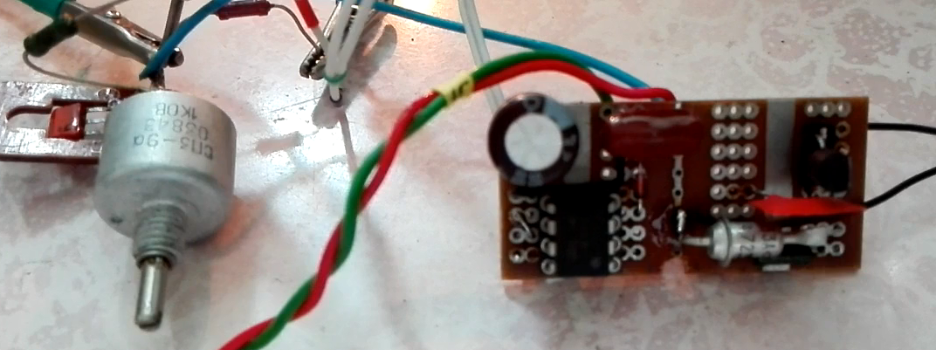

The following shows the waveform of the received signal.
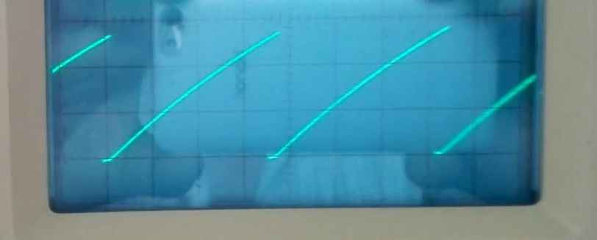

Serve this signal to the input of the driver and power key, which was used in the movie "registration radiantnoj energy-1. Let's see what they will do with our signal?
Load driver, as has already been said is a quick power key, and load the power key is the active load in the form of 12 Volt incandescent 10 Watt power to avoid distortion of the output signal on runoff key.

See a short video snippet:

It can be seen that changing the frequency of the generator does not affect the nature of signal processing and power driver key.

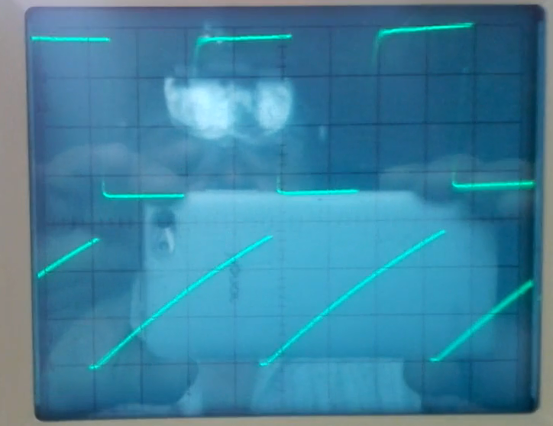

The photo clearly shows that the driver is opened automatically when the threshold voltage. It is the moment the Flash LEDs optoelectronic coupler driver. Than more toughness and input voltage, the better it will work the power keys. It is clear that the power key is not available for work on 12 volts. Well, at least 30 ÷ 600 Volt's key power is justified.

Should not be heavily to pay attention to the signal form. The fact of the matter is that in this time I accidentally magnetized oscilloscope enclosure, so vertical lines look curved. It will be necessary to take measures to oscilloscope only degaussing.

On this, I think, it is possible to put a point in this question.

As always the link to this text can be found in the comments window.

21.05.2017 г.

