Supplement number 1 to the video

"How does an AC capacitor work?"

Dedicated to all true lovers of natural science.

Deina Sergey Alekseevich

1. Introduction

In the previous video, the question was asked how the capacitor will behave in the AC circuit, if you keep it not always on, and turn it on only at the right moment. There are several such moments to choose from, but in this paper, we will focus on one thing - when is the AC mains voltage and on the capacitor plates equal to zero. For this a special experiment will be performed, with a capacitor, which will be discussed in this paper.

2. Scheme of experiment №1

For experience No. 1, a special circuit was assembled, which allows periodically connecting a discharged capacitor to an AC circuit at the very moment when the voltage of the AC source is zero. Similar research work was carried out and shown in the “EMF of self-induction” video, only there the coil was connected together with the capacitor to a DC source.
Unfortunately, my technical capabilities are somehow limited, since I don’t have the generators I would need, and I don’t have time to specially assemble electronic circuits. Nevertheless, I managed the simplest option - an electromechanical vibrator. Scheme of experiment number 1 below.
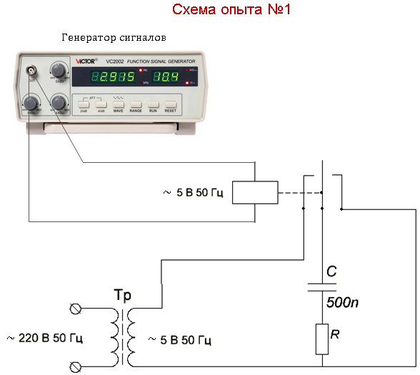

As a switch, a vibrator, manufactured by the USSR industry in the 60s of the last century, is used. In it, the central moving contact oscillates due to the alternating magnetic field created by a special coil, designed for an alternating voltage with a frequency of 50 Hz and a voltage of 6.3 Volts. To the left and to the right of the moving contact there are two fixed contacts, to them the moving contact alternately touches, closing alternately two different electrical circuits.
One fixed contact is used to connect a capacitor to an AC voltage source with a frequency of 50 Hz. Another fixed contact serves to reset the voltage on the capacitor by closing between its two plates.
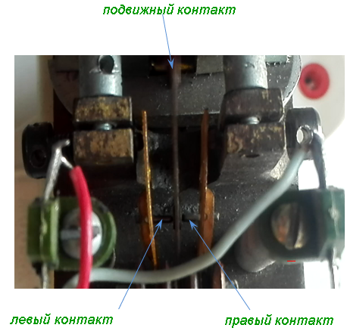

In the photo above it can be seen that the image of the movable contact is not clear due to its vibration. Watch the video clip number 1 of the vibrator:

The essence of the circuit of experiment No. 1 is that with each subsequent closure of the contact:

1) the capacitor would be discharged from the previous charge cycle;
2) at the time of contact closure, the alternating voltage of the power source is zero (Uc = 0).

Below are charts:
a) voltage in the network;
b) the pulse of connecting the capacitor to the network;
c) a pulse resetting the voltage on the capacitor;
g) current in the capacitor circuit.

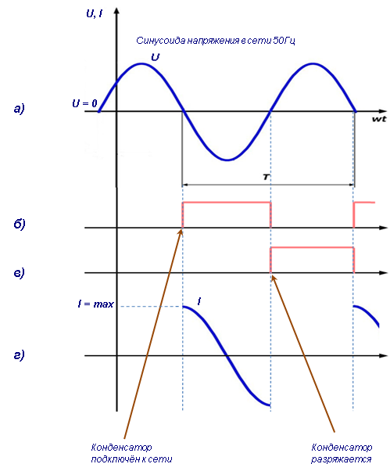

Experience has shown that at that moment, when the voltage in the network is really zero, a current begins to flow through the capacitor connected at that time, and its value is maximal. Have you ever seen a current in a circuit be before a voltage appears in it?
After the first half of the period (when the capacitor was connected to the supply), other contacts are closed and during the second half of the period the capacitor is completely discharged, and thus it is again ready to be connected in the next oscillation period in the power source.
I had to deal manually with the synchronization of the oscillations of the household grid of 50 Hz and the generator of sinusoidal oscillations so that the moment of contact closure coincided at the moment when the voltage in the grid was zero. Because of this, I realized that the fluctuations are in the 50 Hz grid, it is not stable. And even though I had to deal with the synchronization of two frequencies, I still managed to capture the oscillograms of satisfactory quality that I needed.
Watch the video fragment №2 of maintaining balance:

The results of this experiment were filmed in discrete mode, the curves of changes in current and voltage over time and are presented on the oscillogram below and to the left. The current curve turned out to be a bit blurred due to the fact that the current on the shunt is small and had to significantly increase the sensitivity of the oscilloscope which capture the interference in the power grid. But this will not affect the results of the experiment.
For comparison, to the right of this oscillogram is shown the oscillogram of previous experience, with which we have already met, and which was captured in continuous mode.
We are watching the following video clip No. 3 on how the waveform was recorded in continuous mode:

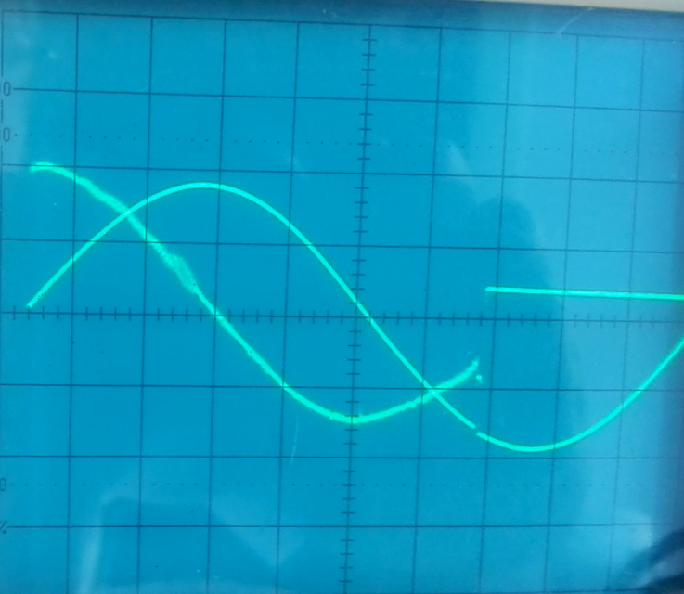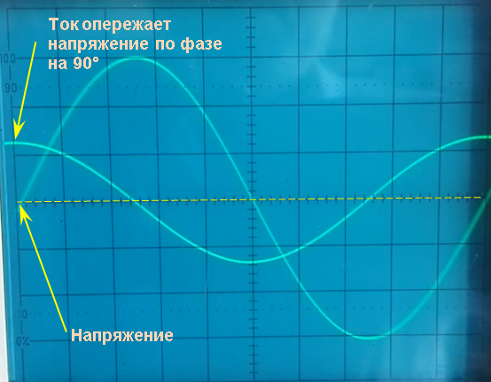

Due to the slightly deregulated contacts on the oscillogram can be seen that the capacitor really begins to discharge later than shown in the diagram, but, nevertheless, it has time to fully discharge in the next cycle.

It is clearly seen that on both oscillograms the curves of the time and voltage variations over time practically coincide with each other. Therefore, when the capacitor is connected to an AC network, and the potential difference across the source of alternating voltage is zero, then the electric current in the capacitor circuit really is present and has the maximum value!

Experience number 2

But that is not all.
In this experiment No. 1, special attention was paid to two points:
1) to synchronize the moment of contact closure with the phase of the alternating voltage oscillations;
2) the moment of changing the direction of the current in the capacitor.

And what will happen if the capacitor is connected to the network not exactly at the time of zero voltage, but a little earlier or a little later?

As a result of the frequency instability in the home network, all the time I had to be alert, since the frequency all the time "went away" sometimes more, sometimes less. Due to the fact that synchronization had to be carried out manually, rotating the fine-tuning knob of the signal generator, I had several cases of mismatch: the moment of closing of the vibrator contacts and the moment the voltage reached zero voltage in the larger and smaller value. As a result, it was found that even with a slight mismatch, the behaviour of the current in the capacitor circuit is fundamentally different from the case when these two points are exactly matched. Experiment No. 2 with all convincingly showed that in this case there is a distortion of the usual shape of the curve of change in current over time.
For example, if the contacts of the vibrator are closed at the moment when the power supply voltage has not yet reached zero, then the current curve takes the form of an exponent, directed upwards. In this case, the direction of the current shows that the dielectric of the capacitor releases the accumulated energy, just as it does with an inductance coil, when its core releases the accumulated energy at the moment when the current is interrupted. This moment is shown in the illustration below, on the left oscillogram.

.
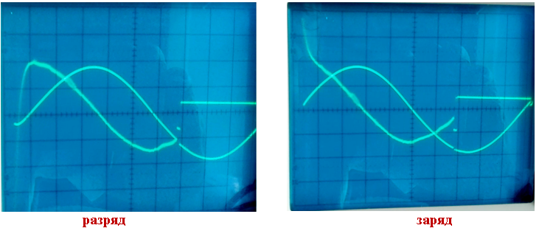
capacitor discharge capacitor charge

On the contrary, if the capacitor is connected to the grid at a time when the voltage value has already passed through zero and has begun to grow, then the current exponent is directed from top to bottom, which means that the current in the circuit has already changed direction and its value tends to infinity! This moment is shown in the illustration above, in the right waveform.
Thus, at a certain angle of imbalance in time of two sources of oscillations, the instantaneous value of the current in the capacitor circuit tends to infinity in the forward or reverse direction, which proves the shape of the current in the capacitor circuit in exponential form. This is a very important observation.
We watch video capture No. 4 about the result of the displacement of the moment of contact closure relative to the moment of zero voltage:

But with the usual connection of a capacitor to an AC source or with full synchronization of the moment of contact closure and the voltage reaching zero, this phenomenon cannot be observed. We will always see only the picture shown on the waveform below. For this reason, I am sure that very few people even suspected the existence of these phenomena.

I recall that, as always, our task is to establish the meaning of the physical phenomena related to the operation of a capacitor in an alternating current circuit. This becomes possible with the accumulation of data from this experience and others.
And so, how can it be that the power supply voltage is zero, and the current in the circuit already exists? It turns out that the current in the circuit and the voltage on the capacitor plates are little related processes. Proof of this is the fact that the current and voltage phases are independent of each other.
For the proof below, two pictures are presented, to which everyone is accustomed from school and on which two known phase shifts of current and voltage are fixed and vice versa. These can be shifted alternating current and voltage in an electrical circuit, electromagnetic waves, or reactive current and voltage.

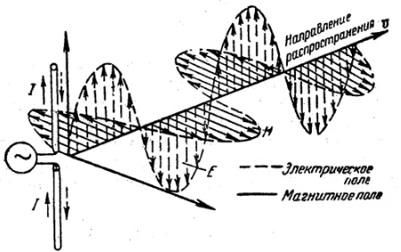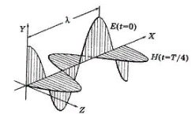
идеальный последовательный колебательный контур
идеальный параллельный колебательный контур

The left diagram shows a phase shift equal to zero, which may occur in an ideal serial oscillatory circuit. The right diagram shows a phase shift of 90 °, which takes place in an ideal parallel oscillatory circuit. But a phase shift of 0 ° and a phase shift of 90 ° represent only two extreme cases, but the actual shift is always between these two values ​​and is determined by the value of the impedance, the active resistance in the circuit or the load connected to them.
But that's not all. Cases of transformation of the sinusoids themselves are possible, both with constant phase relations and their relative shift by 180 °.
Let's watch a short video clip No. 5, confirming what was just said:

Armed with ideas about the properties of the World environment or any other environment, one should always bear in mind that the deformation of any environment is always accompanied by electrical as well as magnetic effects (depending on the aggregate state of a particular environment). In addition, the medium itself can change its aggregate state depending on the intensity of the longitudinal waves themselves, then it is a function of the intensity! This applies primarily to the ether, but it is also possible for other media.
We also take into account that there are longitudinal and transverse waves that can propagate in all media. As a result, we will inevitably come to the conclusion that electric current is a form of propagation of longitudinal deformation waves in a dielectric medium, which are accompanied by piezoelectric effects as a result of the deformation of this medium. In addition, being in a solid state of aggregation, in addition to longitudinal waves, the medium is also a conductor of transverse waves. But the transverse deformation of the medium leads to magnetic effects, which are significantly different from electrical effects.

In our experience, the power source in the form of the secondary winding of a step-down transformer at a 220-volt substation creates two types of waves in conducting media (electrical wires):
1) longitudinal waves propagate near and around the wires at a speed of about 3 · 108 m / s. These waves are accompanied by piezoelectric effects in the World environment.
2) due to the fact that the conducting medium is in a solid aggregate state, it is a conductor of transverse waves propagating in them at a speed of about 3,000-6,000 m / s. These waves are accompanied by magnetic effects and are known as magnetostriction.
But for now, it is still too early to move on to new concepts and terms. We will continue to collect the actual material.

Continuing research in the following papers.

04/20/2019

