How does an AC capacitor work?

Deina Sergey Alekseevich

1. Introduction

The coil and the capacitor are two key elements, without them it is impossible to build an electric BTG. It was on these that N. Tesla relied in his research. The reason for this is that the BTG must necessarily be an open, not a closed system, due to which it becomes possible to capture and transform free energy propagating in the form of longitudinal waves of deformation of the surrounding World environment.
The principle of capturing energy and the range of its pulsations is the personal choice of each researcher, his resources, capabilities and competence.
In my previous works “EMF of self-induction”, “Supplement1 and Supplement 2 to the video “EMF of self-induction” and “Antiphase”, the interaction of inductors with their cores or surrounding environment was studied in detail.
The inductor has a transverse effect on the environment due to the magnetic permeability of the medium μ. It was shown that if the environment does not affect the material from which the core of the inductance is made, then there is no hope of receiving additional energy apart of which went into deformation of the core of the coil.
But can a capacitor affect the environment? If it can, how?
The fact is that a dielectric in a capacitor plays a similar role as a ferromagnetic core plays in an inductance coil. The impact that the capacitor plates have on the dielectric and the environment, due to the dielectric constant ε of the medium, is not transverse, like that of an inductor, but longitudinal.
Whatever properties of coils and capacitors we consider, they will always be in relation to eachother.

After research work with coils, it would be logical to continue this work with capacitors and its interaction with the dielectric or the external environment, especially since here we will have a lot of interesting and unusual effects. This series of experiments is devoted to this interesting and very important topic.
I recall that inductance coils with a closed core are a closed system, which excludes the possibility of its interaction and energy exchange with the external environment. On the contrary, the open core of the inductor, which is an open system with it, will allow the interaction and its exchange of energy with the external environment.
Similarly, there are two types of capacitors, which together with the dielectric, are a closed or open system between its plates. For example, the lone capacitor N. Tesla, which he installed on top of a high-voltage coil, is an open system, which allows him to interact and exchange energy with the external environment. On the contrary, a capacitor whose dielectric is located between two plates is a closed system, therefore there can be no direct interaction with the external environment.
But one must be realistic and take into account that in reality there are many types of energy and methods of their transformation. For example, you can organize the conversion of thermal energy of the environment into electrical energy of the dielectric and vice versa. Then even a capacitor, which is a closed system, can act as an intermediary between the environment and the source of electrical energy.
The same can be said about the inductance coil with a closed core. With its help, it is possible to capture the thermal energy of the environment and convert it into magnetic energy, since the supply of thermal energy in the Earth’s atmosphere is huge - the average ambient temperature is more than 250 ° Kelvin! It is clear that the operation of such devices will be accompanied by the cooling of materials: at the coil, the ferromagnetic core, and at the condenser, the material of the dielectric. The same applies to other types of energy conversion, but this will be discussed in other works.

2. How does a capacitor work?

On the Internet you can find a lot of videos, which demonstrate the unusual properties of dielectrics used in capacitors, as well as the independence of the accumulation of electrical energy in the dielectric from the conductive plates of the capacitor. Do you think that we know everything about capacitors?
Now we are watching a video fragment from a video clip titled “Charge of a dielectric”:
Fully watch the video titled "Charge dielectric" and others on this topic can be viewed on the Avgust May channel via this link: https://youtu.be/_Y48i9G_HC8

This video shows that we really far from knowing everything about capacitors! We will fill this gap.
The simplest capacitor is an air dielectric capacitor. The use of mica, polymer and other dielectrics between the plates of a capacitor significantly improves the energy properties of capacitors, their ability to accumulate electrical energy.

For better mutual understanding, let's make the following convenience:
1) for the direction of the electric current in the circuit is considered to be the movement of electric charges from the positive pole of the power source to the negative pole;
2) a capacitor is considered discharged if the voltage on its plates is zero, and vice versa;
3) if the trace on the oscilloscope screen shows the voltage at the power supply terminals above the zero line, then the terminal to which the oscilloscope signal probe is connected has a positive pole, and the common wire of the probe is connected to the plate having a negative pole;
4) if the trace on the oscilloscope screen shows the voltage on the capacitor plates above the zero line, then the capacitor plate to which the oscilloscope signal probe is connected has a positive charge, and the common probe wire is connected to a negative charge plate;
5) if the trace on the oscilloscope screen shows the voltage at the two terminals of the inductor above the zero line, the coil terminal to which the oscilloscope signal probe is connected has a positive potential, and the common wire of the probe is connected to the negative potential terminal.
6) the direction of the current in the circuit is checked using a diode connected to the open circuit, or by the polarity of the voltage drop across the shunt resistor connected to the open circuit, as described in paragraph 3).
7) the polarity of the voltage drop across the shunt resistor iOS indicates the direction of the current in the circuit. For our work it is very important to know.

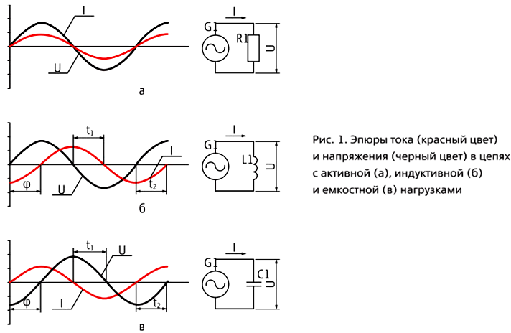The results of this work and subsequent additions to it will later be used as factual material for the continuation of works from the series entitled “Ether - World Environment”.

3. Preparation for the experience

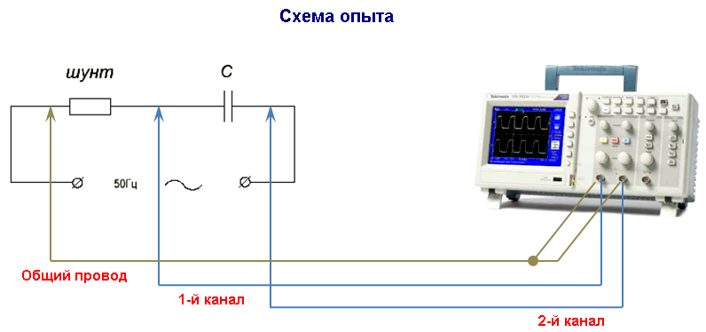
I recall that if the trace of the oscilloscope of the 2nd channel rises above the zero line, then the voltage on the right capacitor plate has a positive polarity, and vice versa. If the trace of the first channel showing the voltage drop on the shunt rises above the zero line, this indicates the forward direction of the current in the capacitor circuit, and vice versa.

4. Conducting experience

We assemble the indicated circuit, conducting an experiment with a capacitor and take an oscillogram of alternating current and voltage in the circuit with a capacitor, as shown in the circuit of the experiment.
Do not forget about safety. It would be better if the capacitor is not connected directly to the network, but through an isolating transformer.
The absolute values ​​of current and voltage in this experience will not be of interest . The yellow dash-dotted line on the oscilloscope screen indicates the zero value. The position of the traces above it correspond to a positive voltage value, as well as a voltage drop across the shunt. The position of the traces below it corresponds to the negative value.
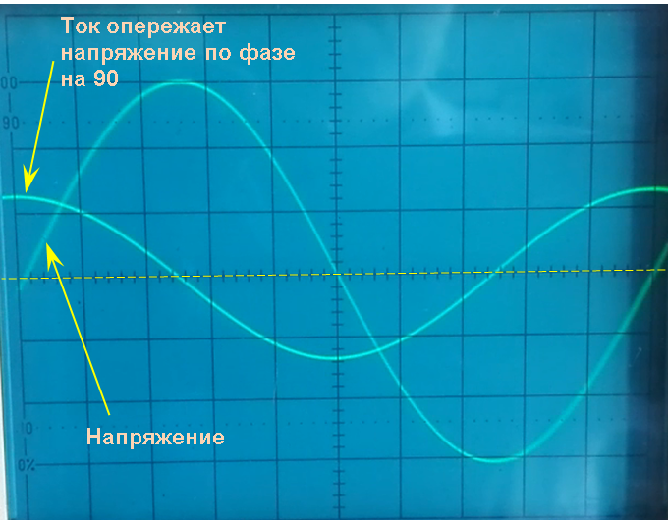

The oscillogram clearly shows that when the alternating voltage in the circuit is still zero, the current in the capacitor circuit has already reached its maximum and is ahead of the voltage in phase by 90 °, that is, the voltage reaches its maximum only after a quarter of a period.
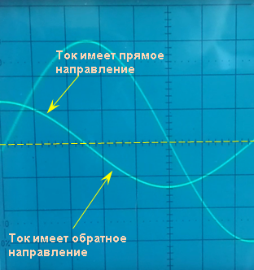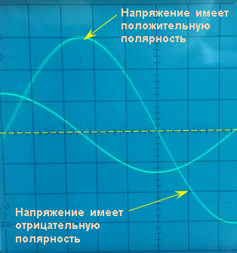

Thus, using an oscilloscope, we were able to determine exactly in which part of the period the voltage takes positive values, and in which - negative, and where the current has a forward direction, and where the opposite is.

A similar oscillogram was shown in a video called “EMF of self-induction”. It was shown that, on the contrary, the voltage on the coil reached a maximum when the current in the circuit was zero, and even had a negative polarity. This fact provoked a wave of indignation among the public, but against the facts you can't fight, as it is said, and the discussion gradually began to subside.
Questions “WHY” will arise and this is normal until the physical meaning of these phenomena is precisely established. But as always in textbooks, instead, we are “fed” with vector diagrams and mathematical formulas trying to convince us they are the pinnacle of physical science. I affirm that where formulas begin, there begins the field of engineering, the purpose of which is to calculate and optimize the design or operating modes of a particular device. But engineering science with its formulas has no relation to the science of physics, since it sheds no light on the physical meaning of any physical phenomenon. To juggle with formulas is nothing more than a habit of resorting to the only, all imposed and not the most perfect of all possible models. Let's try to fill this gap and expand the horizons of physical science.
In our experience, we must find out the reason (establish the physical meaning) of the current advance from the voltage in the capacitor circuit, and, as is known, this is not part of the engineering task. But for real researchers, these advances and lags should be the object of the closest attention, since the true physical meaning of the phenomena lies behind them, so this we will do in this and other works.
In the video “EMF of self-induction” it was shown not only that the voltage is ahead of the current, but also the polarity of this voltage was established at the first moment of the switch closure. This is how the oscillograms looked like a half of the coil charging period, and the capacitor charge, which made up a sequential oscillating circuit, as well as oscillograms of the current in the coil.
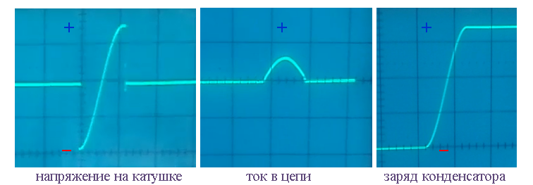

The result of this experience has caused an ambiguous attitude on the part of the public, since many simply do not keep in mind that at the very first moment of connecting the coil to a voltage source, there is already a voltage at its ends, and it is of reversed polarity than the power source. It was always like this - the “new” always takes root with difficulty. Let's see how the audience will now meet the results of the experiment with a capacitor.

In a capacitor, in contrast to an inductor, the current, on the contrary, is ahead of the voltage. In addition, thanks to this experience, it is well established that the current at the time when the capacitor is connected to an electrical circuit, has a direct direction.

We will continue our work and transfer the data obtained in the oscillogram onto a diagram showing one period of current and voltage oscillations. Green sine wave shows voltage change, and blue sine wave shows current. We divide the period of oscillation 360 ° into nine parts - subperiods, with a duration of approximately 45 °, as shown in the diagram below.
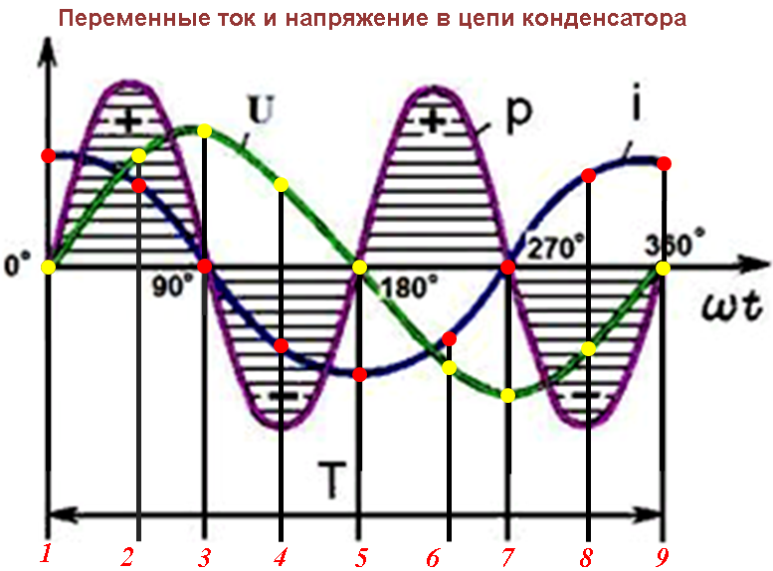

We mark these nine periods on the sinusoids of current and voltage by colored dots. Red dots mark the beginning of 9 sub-periods of current change, and yellow dots mark the beginnings of the same sub-periods of voltage change.

5. Recording experience data

In this paragraph of the work, we restrict ourselves to registering qualitative phenomena without their interpretation. Below we place the results “as it is” of all nine temporary sub-periods. Our task will be to look at the fixed values ​​of the current and voltage on the diagram (for each time subperiod), transfer them to the circuit indicating the polarity of the voltage and the direction of the current in the circuit, and if necessary add required comments.
___________________________________________________________________________
Time sub-period №1: the beginning - the capacitor is completely discharged
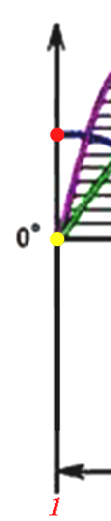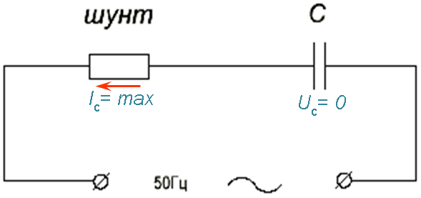
In the diagram, the voltage value is indicated by a yellow point, which is located at the origin, therefore, in the first subperiod, the voltage of the power supply and on the capacitor plates is zero, therefore in the circuit we write: Uc = 0.
We “read” the direction of the current by the polarity of the voltage falling on the shunt (we will not show it). In the diagram, the current value is shown by a red dot located on the positive part of the y-axis. Here the voltage drop across the shunt has a positive polarity, therefore, the current in the circuit has a positive direction. Let's designate it as a red arrow.
This fact is elementarily verified by installing a diode between the shunt and the capacitor so that the current in the circuit is not zero. If, as a result of a change in the polarity of the diode, the current in the circuit becomes equal to zero, then we return to the previous polarity of the diode and consider the direction of the current as established.
_____________________________________________________________________________
Temporary sub-period number 2: the capacitor is charging
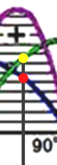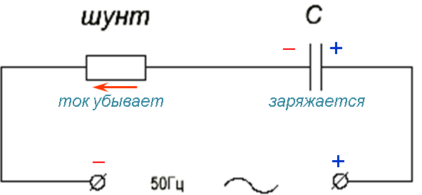
The capacitor charges positively because the voltage on its plates increases and has a positive value (the yellow dot in the diagram is located on the positive voltage wave). We write it down.
Here the current (red dot) does not change its direction, but decreases. The diagram shows an arrow as the current from the positive terminal of the source of alternating voltage flows to the negative terminal.
_____________________________________________________________________________
Time period 3: capacitor charged

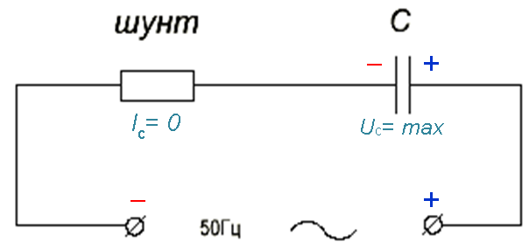
The voltage on the capacitor plates (yellow dot) still has a positive value and reaches its maximum value.
The value of the current in the capacitor circuit has reached zero. We write it down.
_____________________________________________________________________________
Temporary subperiod №4: the capacitor discharges

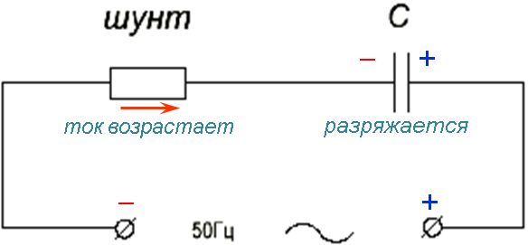

The voltage on the capacitor plates is still positive, but it begins to decrease, as the capacitor discharges here.
The current in the circuit (red dot) increases, but now flows in the opposite direction, as indicated by a negative value of the voltage drop across the capacitor shunt (the red dot on the diagram is below zero). We show this on the diagram by an arrow.
_____________________________________________________________________________
Temporary subperiod №5: capacitor discharged

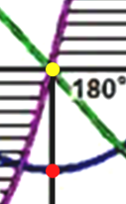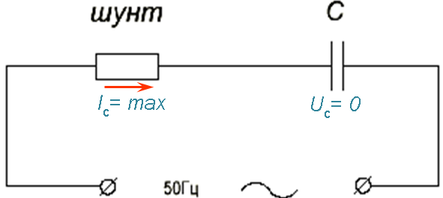
The voltage on the capacitor plates reached zero (yellow dot in the diagram).
The current in the circuit continues to move in the negative direction and reached its maximum. We write it down.
_____________________________________________________________________________
Temporary subperiod №6: the capacitor is charging

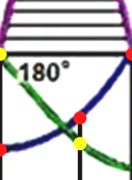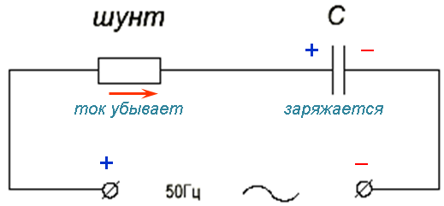
In the sixth subperiod, the capacitor is charged negatively, that is, the voltage on its plates (the yellow dot on the diagram) continues to increase its negative value.
Here, the current in the circuit still has a negative direction, but its value decreases. We show it in the diagram.
_____________________________________________________________________________
Temporary subperiod №7: the capacitor is charged

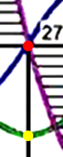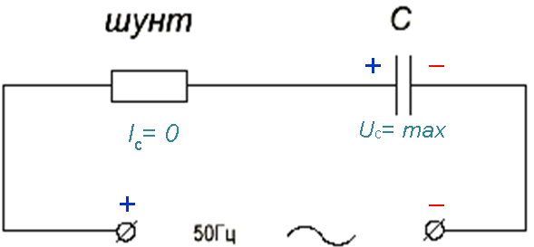
In the seventh subperiod, the voltage (yellow dot in the diagram) reaches a maximum of a negative value.
Here the current reaches zero. We show it in the diagram.

_____________________________________________________________________________
Temporary subperiod No. 8: capacitor discharging

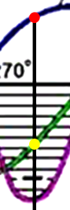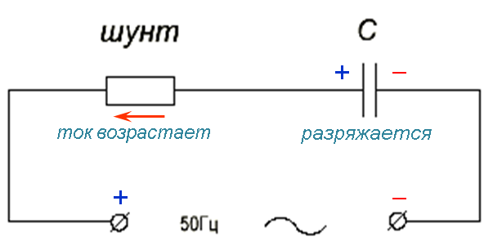

In the eighth subperiod, the capacitor is discharging, as the voltage on its plates began to decrease in absolute value, although it did not change its polarity.
Here the current increases and has a positive direction. We show it in the diagram.
_____________________________________________________________________________
Time period 9: capacitor discharged again

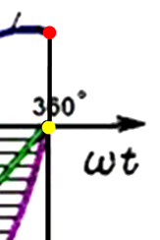
In the ninth time sub-period, the current and voltage again took on the values ​identical ​that they had in the first sub-period, at the beginning of the period of oscillation. And with this a qualitative description of the phenomena can be considered complete.
_____________________________________________________________________________

6. Analysis of the results

At this point, we will use the results of the work done in the 5th paragraph, and we will interpret what we recorded on the charts relating to each of the nine time subperiods (into which the period of one oscillation, 20 ms long, was divided). Here each of the 9 sub-periods will be considered separately and its physical meaning is established.
To understand the processes occurring in a condenser, it is necessary to consider separately four phenomena that have long been described in science, but their physical meaning is still unknown to it:
1) reactive voltage is a wave of longitudinal deformation of the ether medium in the form of compression-discharge, which moves outside the conductor, which, in G. Nikolayev, is called a scalar magnetic field.
2) the reactive current is a wave of a transverse wave of deformation of the ether medium, which propagates outside the conductor and propagates perpendicular to the surface, which is called a vector magnetic field in G. V. Nikolaev.
3) voltage is a real analogue of a reactive voltage, that is, a longitudinal wave of deformation in the form of compression-discharge, but in a conducting medium it takes the form of a spatial separation of real charges for their excess and deficiency.
4) the current is a real analogue of the reactive current, that is, a transverse deformation wave in the form of twisting-stretching, but in a conducting medium it takes the form of a spatial twisting - skin effect and movement of real charges in it;
All these four phenomena do not exist by themselves, but depend on the state of aggregate of the environment in which they manifest, including the World environment - the ether. They are interrelated and interdependent. More on this will be discussed in a separate paper. And now, we will continue our research work.
In one cycle, the oscillations of the capacitor dielectric are subjected to two types of deformation - compression and discharge, which leads to a change in the polarity of the voltage on the capacitor plates. As a result, we must distinguish between 8 phases of deformation of the dielectric:
1) the balance between compression and discharge;
2) increase in compression;
3) maximum compression;
4) decrease in compression;
5) equilibrium between compression and discharge;
6) increase in discharge;
7) maximum discharge;
8) decrease of discharge;
9) the balance between compression and discharge.

1) In the first time subperiod, the wave of longitudinal deformation (dielectric polarization) is in the middle between discharging and compression and remains in a dynamic state.

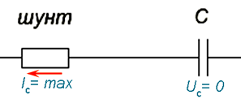

Here, the capacitor is completely discharged, the voltage on its plates and the power source is zero, although there is already a current in the circuit, and its value is maximum! This is clearly seen on the oscilloscope screen at the beginning of each period.
Compare this with the behavior of self-induction EMF at the inductor. There, the current, on the contrary, is still zero, and the voltage at the ends of the coil is already maximal, and it also has a polarity opposite to the power source.
How can this be? What is the physical meaning behind this? It is already clear that it is impossible to answer the question of why the current is ahead of the voltage or the voltage that is ahead of the current without recognizing that the environment is involved in these phenomena.

2) In the second time subperiod, the wave of longitudinal deformation (dielectric polarization) passed from the equilibrium point between compression and discharge and entered the dielectric compression phase, which will end with its maximum and temporary static state.
A propagating wave of longitudinal compression-discharge in the environment surrounding the conductor reaches the capacitor, creates a voltage in its dielectric, which we perceive as polarization of the dielectric. Due to the conductive properties of the capacitor plates, it is trapped.
Many already know that the charge in the capacitor plates has nothing to do with electrons.
Watch a video fragment called"Leyden bank charge" on the link: https://yandex.ru/video/search?filmid=1421538357729072442&p=1&text=где%20находится%20заряд%20конденсатора&noreask=1&path=wizard

Go ahead. The diagram below shows the direction of the wave of longitudinal strain (which the diode transmits in the same way as the current of real charges). Due to the wave, the dielectric of the capacitor is in the process of polarization. Polarization, as is known, is another name for the piezoelectric effect and suggests that energy in a dielectric is stored in the form of electrical voltage, which is created like a mechanical voltage and is accompanied by changes in the linear dimensions of the dielectric in the direction of polarization.

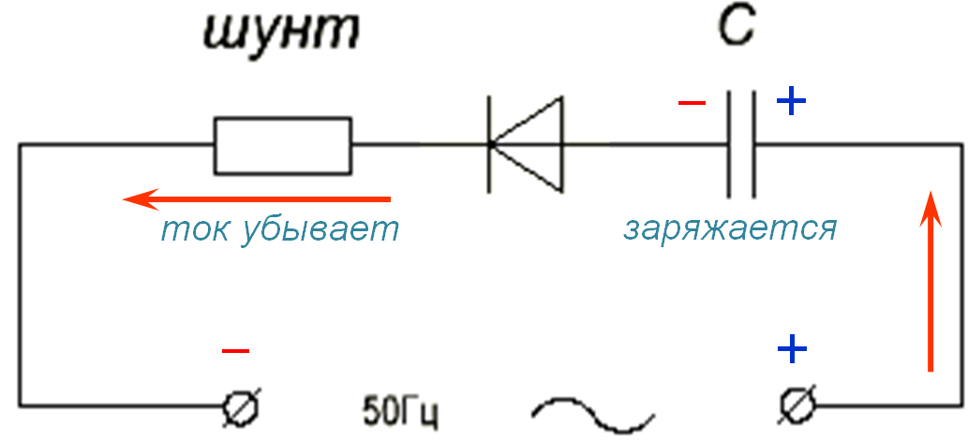
The capacitor plates fix and hold the dielectric deformation wave (i.e., the deformation in the dielectric) between the capacitor plates. In order to remove this voltage, it is enough to close the capacitor plates between each other, due to which the potential energy of polarization of the dielectric will again turn into kinetic energy, but in the form of the motion of charges in a conducting medium. Thus, the transformation of one type of energy into another is carried out.
Important! In the second sub-period, the capacitor is an energy consumer. One of its lining is charged from the plus power source, and the other from the minus. It is easy to verify this if, mentally or by experience, we put a diode in the capacitor circuit, as shown above. If you change the polarity of the diode connection, the capacitor will not charge. This fact is real proof that in this subperiod the capacitor is not discharging, but charging! The capacitor transforms the energy of the wave of transverse deformation of the medium (vector magnetic field) into the polarization energy of the dielectric and charge separation, as the current curve decreases and the voltage curve increases — one passes into the other.

3) In the third time sub-period, the wave of longitudinal deformation (dielectric polarization) reached its maximum in the compression phase, and the process is temporarily in a static state.

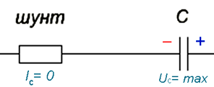
The dielectric is maximally compressed (that is, polarized) by the energy of the longitudinal strain wave, as a result, the voltage on the capacitor plates reached a maximum. In this case, the current in the circuit reduced its value to zero, which is evidence of the completion of the polarization of the dielectric.
There is voltage on the plates, but there is no current in the circuit.

4) In the fourth time sub-period, the longitudinal strain wave (dielectric polarization) stops in the compression phase.
In this case, according to the law of sine, the voltage of the power source decreases, as a result, the capacitor begins to discharge, becoming in this time period a source of energy, giving it back to the power source.
Now the potential energy accumulated due to the polarization of the dielectric of the capacitor is transferred to the energy of motion of charges in the conductor.

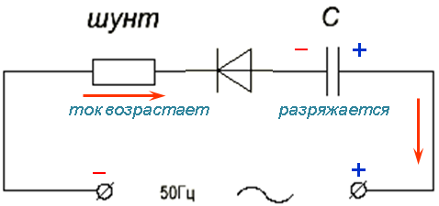
This is clearly seen in the change of direction of the current in the circuit (red arrow), although the polarity at the power supply terminals and capacitor plates have not changed! Another way to explain this direction of the current is impossible.
It is possible to prove the change of direction of the current in the circuit, as in the second subperiod by installing a diode in the circuit, as shown in the figure above.

5) In the fifth time sub-period, the wave of longitudinal deformation (dielectric polarization) is again in equilibrium between discharge and compression.

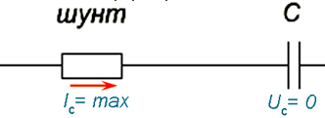

Interestingly, here the current again reached its maximum value at a time when the voltage on the capacitor plates and power supply terminals had already reached zero. This is due to the reverse movement of the wave of longitudinal deformation of the conducting medium, which obeys only its laws and cycles. Here the wave has reached its maximum strain rate and it can be seen that the dielectric voltage is secondary, it is a consequence of the movement of the compression wave and can last indefinitely if the leakage currents in the capacitor are infinitely small.

6) In the sixth time subperiod, the wave of longitudinal deformation (dielectric polarization) entered the discharging phase. In this case, the polarity of the voltage of the power supply was reversed.

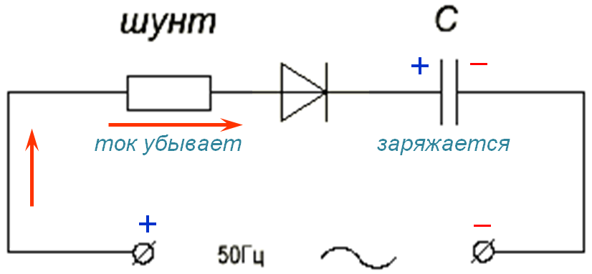

The figure clearly shows that the current of real charges in the circuit now flows from the plus of the power source to the corresponding capacitor plate, and the capacitor from the source has again become a power consumer. The diode is shown to remind viewers that everything can always be checked.

7) In the seventh time sub-period, the deformation wave (dielectric polarization) reached its maximum, but already in the discharge phase. For this reason, the polarity of the voltage on the capacitor plates is reversed.
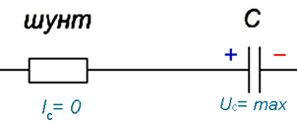

In this static phase, the real charge current is also stopped.

8) In the eighth time sub-period, the wave of longitudinal deformation (dielectric polarization) ends in the discharge phase.
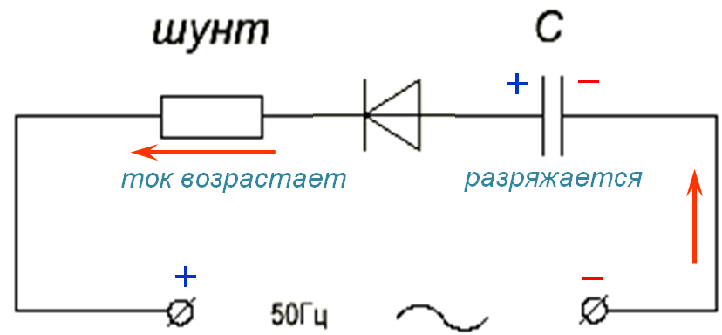
The capacitor again became a source of energy, which is now returned back to the power source, while the capacitor is discharged. This is clearly seen in the diagram, since the current in the circuit is directed from the positive terminal of the capacitor to the positive terminal of the power supply. The diode is shown again for reminder.

9) In the ninth time sub-period, the wave of longitudinal deformation (dielectric polarization) is again in equilibrium between discharge and compression.
Finally, all forms of movement in one period of oscillation are fully completed, and we again find ourselves at the very beginning, but already the second period of oscillation, the processes of which will be completely identical to the processes occurring in the first period.

7. Analysis of the results

Many channel visitors, having begun to watch the video, will ask, so what’s so special about it? This has long been all told and shown in the books.
Indeed, it would seem, everything is clear, except for a few minor details. All right, you will think, there is a current, but there is no voltage, or for some reason the direction of the current in the capacitor circuit does not correspond to the polarity of the voltage on its plates.
No, it is not okay, but with these seemingly insignificant trifles one big misunderstanding has grown.
The search for answers to this and similar questions is the search for physical meaning, which is the subject of real physical, not engineering science. Not a single formula, not a single vector diagram, being defined and limited by one or another physical model, will never give an answer to such questions and will not reveal the content of physical meaning. Therefore, in no textbook you will find answers to questions about the physical meaning of the processes occurring in a capacitor for the simple reason that someone decided that no one should be interested.
But we will go the other way and look for answers to our WHY?
First of all, let's answer the question of how a capacitor will behave in an alternating current circuit if it is switched on not at random, but only at the right moment when the voltage on its plates is zero. To do this, you will need to conduct the following experiment with a capacitor, which will be discussed in Appendix No. 1 to this video.

8. Brief comparative characteristics of the properties of inductors and capacitors

The results of previous experiments with coils and capacitors allows us, finally, to make a brief comparative analysis of the properties of these two major components of electrical circuits.

1. Рост тока | медленный | быстрый
2. Скорость заряда среды | медленная | быстрая
2. Скорость разряда среды | быстрая | Медленная (по экспоненте)
5. Сопротивление при включении | стремится к бесконечности | стремится к нулю
5. Сопротивление при выключении | стремится к активному (нулю) | стремится к бесконечности
7. Деформация окружающей среды | поперечная | продольная
6. Опережает | напряжение $→$ ток  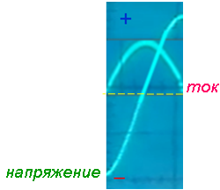 | ток $→$ напряжение  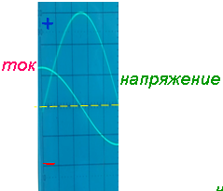
3. Аккумуляция энергии в среде в виде: | ЭДС самоиндукции  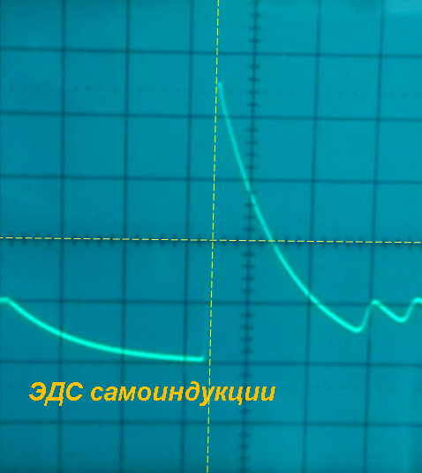 | поляризации диэлектрика  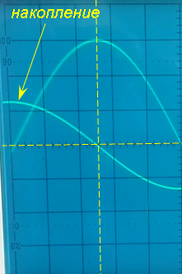
4. Отдача энергии из среды в виде: | Обратная ЭДС  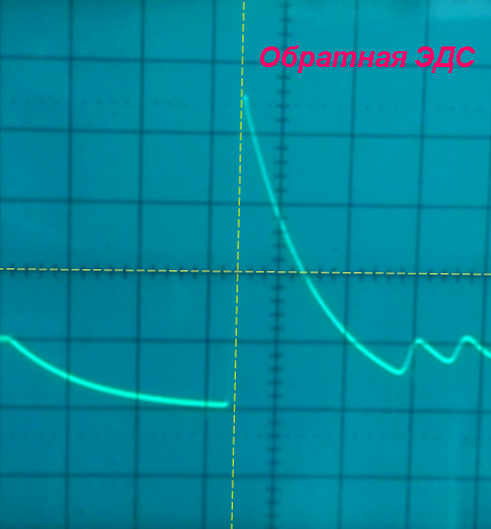 | нейтрализации диэлектрика  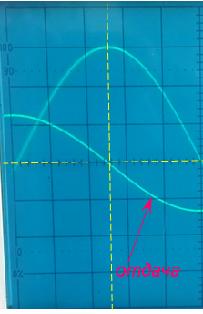

Research of the condensetry will be continued in addition to No. 1 to this vicinity.
19.04.2019 г

