Magnets. Magnetic field of Nikolaev - 7
Experience in registering a scalar magnetic field

Deina Sergey Alekseevich

This experience is an alternative to two experiments called Магниты Второе магнитное поле Николаева -3 и Магниты Второе магнитное поле Николаева -4,
which can be viewed on my channel.
Visitors to my channel in the comments to some of my experiments asked me a completely fair question: “Is it really impossible to record a scalar magnetic field in a longitudinally magnetized ring? Магниты Второе магнитное поле Николаева -2, показанного там, на 2-й
Minute?
Two rings were made of Alnico alloy (UNDC alloy - an alloy of iron (53%), aluminum (10%), nickel (19%) and cobalt (18%)). In reference books it is possible to find the value of induction B for this alloy. It is very insignificant for several reasons, including for some technical reasons related to the initial direction of the magnetization of the workpiece.
"Why not show the experience of the force interaction of scalar magnetic fields between two such magnetized rings?"
The answer to these questions lies in the fact that these rings have achieved a very weak magnitude of magnetic induction due to the large diameter of the inner hole, the small cross section of the magnetic material and the impossibility of magnetizing this alloy more than the Alnico fame structure allows. As a result, the interaction force of the scalar magnetic field of these rings is at the level of measurement error.
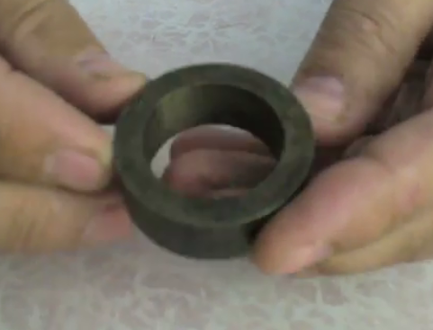
Фото 1

The decision to conduct an experiment based on scalar force interaction came unexpectedly when suddenly we were talking about a magnetic guardian, once opened by Edward Lidskalninsh. There is a lot of literature on the Internet about this.
Indeed, if two U-shaped iron bars are folded together with the ends in such a way that a closed magnetic circuit is formed and a coil with current is attached to one of them, then when the current is fed into the coil, the rods are magnetized with the ends to each other. But after switching off the current, they will still remain magnetized, and it will be very difficult to separate these two rods. They will be strongly pressed to each other indefinitely. But if the rods are still separated, they will lose their magnetic properties, and in the iron there remains a very weak magnetic field, called coercive force.
Therefore, it was decided to make two split cylinders made of magnetically mild steel, for example, Art. 3 ÷ Art. 5, which has a large magnetic permeability of about 700, cut them in half and sand the cut surfaces for a good fit.
Watch the video fragment 1.
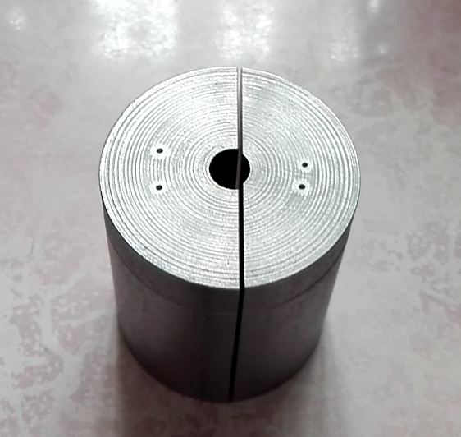
Фото 2
If you now put together the two halves of the cylinders and magnetize them by supplying current through a conductor passed through them, exceeding the saturation value of the material magnetization, you can achieve much greater magnetic induction in them than in Alnico alloy rings. The halves will magnetize and remain tightly pressed to each other until they are separated with the help of an externally applied force.


Фото 3
Figure 3 shows a photo of two folded cylinder halves and a threaded conductor for magnetization. Thus, using a car battery, two tori were magnetized and, judging by the efforts to break the halves of the tori, the magnetic induction reaches values ​​up to 1 T.
Watch video fragment 2.

The force interaction of the cylinders can be enhanced if: when magnetizing, skip a current of greater magnitude; apply materials with a large value of µ; reduce the distance between the cylinders; by some other measures.
We watch video fragment 3.

According to the theory of vector potential A of a magnetic field, any magnetized object has two components of this vector potential — rotA, a transverse component, called a vector magnetic field, and -divA, a longitudinal component, called GV Nikolayev’s scalar magnetic field.

And so, when the electrical circuit is opened, the halves of the torus remain drawn to each other. Now it is an established fact, therefore, in the torus there is a component of the vector potential in the form of a closed vector magnetic field (rotA). This means that the second component must also be present in it in the form of a scalar magnetic field (-divA). Therefore, the second stage now I should register this scalar magnetic field, as the second component of the vector potential A.
To register the scalar magnetic field, an installation was assembled from a tripod on which the first magnetized cylinder and electronic scales are mounted, on which the second magnetized cylinder is located. The position of the first cylinder in height relative to the second cylinder is adjusted so that the ends of the two cylinders are parallel to each other and there is a small gap between them.
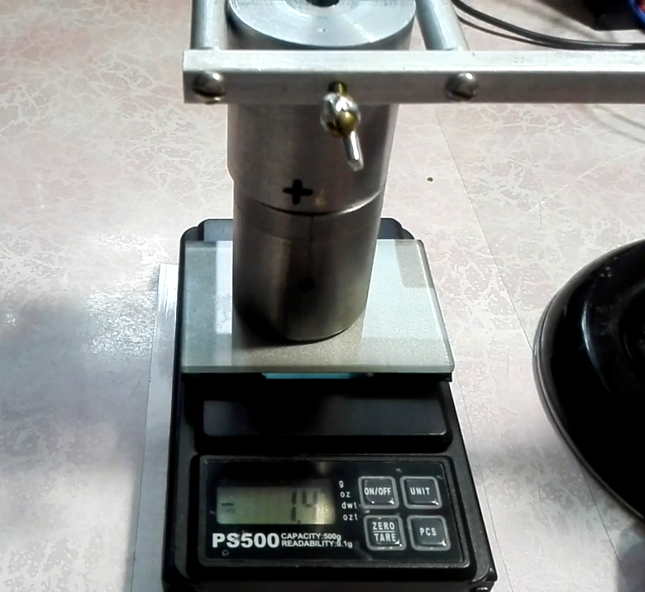
Фото 4
Watch video clip 4.
The tripod together with the first cylinder fixed on it can smoothly move along the table surface so that the surfaces of the ends of the two cylinders do not touch each other, and the overlap area of ​​the ends of the two cylinders is variable. In this case, it is possible to observe the change in the weight of the second cylinder on the scales as a result of the force interaction between the two cylinders. In addition, the second cylinder can be rotated around its axis relative to the first cylinder, observing how different inhomogeneities manifest themselves.
As for the force interaction that interests us most, it can in no way be due to the vector magnetic field, since it is completely concentrated inside the ferromagnetic material, with the exception of weak scattered magnetic fields.
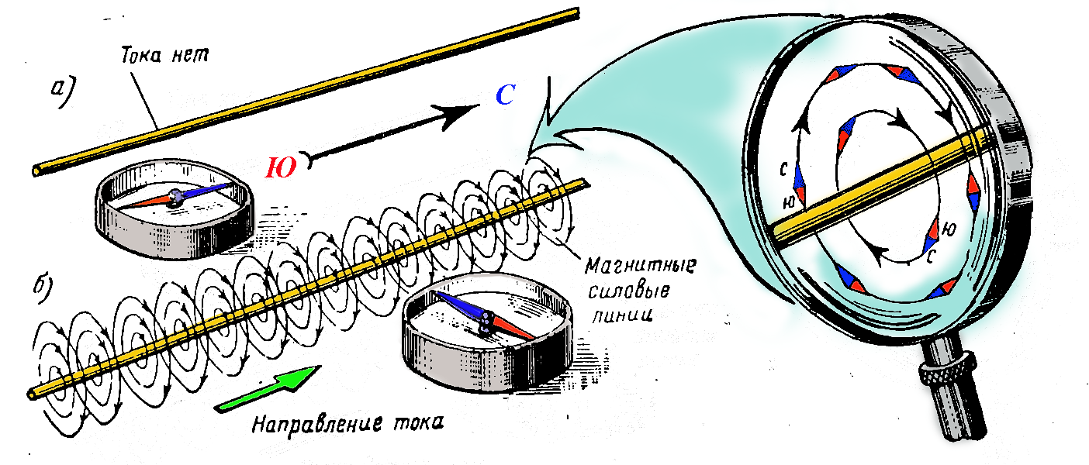
Рис. 1

In this experience, we are most interested in the proof of the possibility of force interaction of cylinders, the induction vector of which has the form of closed concentric lines, as shown in Fig. 1 (taken from the Internet), with the difference that they are inside a ferromagnetic material, therefore reinforced in µ times
Watch the video fragment 5.

I repeat, this experience is aimed only at conducting a qualitative assessment of power interaction. Fragment 5 shows the change of 8 positions of the second cylinder relative to the first cylinder torus, in each of them the measurement of the weight of the second cylinder was carried out. To turn the first cylinder does not make sense, since the measurement results will be the same. Experience has shown that in all cases the change in weight of the second cylinder was only in the direction of reducing its weight, that in all cases there is an attraction of two cylinders. This fact compels us to take a fresh look at the nature of the scalar magnetic field. The negative result of the experiment can be considered as the identified heterogeneity of force interaction during the turns of the second cylinder. This can be explained by the fact that:

1) cuts are made not exactly in the center of the cylinders, which can be clearly seen with the naked eye;
2) the cylinders are cut, which leads to the appearance of scattered vector fields caused by the significant surface roughness of the tori;

Based on the data obtained as a result of the experiment, it is clear that there is a sense to put another, but not qualitative, but quantitative experience, in which there will be no need to cut the cylinders, and to increase the interaction force, reduce the height twice. It will be possible to perform an accurate quantitative assessment of the force interaction of the scalar magnetic field of two cylinders and to give it a modern theoretical justification.

To be continued.

07.31.2017

